**HOSTEL MANAGEMENT SYSTEM**

**A MINIPROJECT REPORT**

***Submitted by***

**KEERTHANA V (953620104025)**

**HARINISRIVALLI V (953620104014)**

**BACHELOR OF ENGINEERING**

**IN**

COMPUTER SCIENCE AND ENGINEERING

**RAMCO INSTITUTE OF TECHNOLOGY,**

**RAJAPALAYAM**

**BONAFIDE CERTIFICATE**

Certified that this miniproject report **“****HOSTEL MANAGEMENT SYSTEM”** is the bonafide work of **“KEERTHANA V (953620104025)”**

,**“HARINISRIVALLI V (953620104014)”** who carried out the miniproject work under our supervision.

|  |  |
| --- | --- |
| **SIGNATURE**  Dr.K.Vijayalakshmi M.E., Ph.D.  **HEAD OF THE DEPARTMENT**  Department of Computer Science  and Engineering  Ramco Institute of Technology  North Venganallur Village  Rajapalayam – 626117 | **SIGNATURE**  Mr.K.VigneshSaravanan B.E.,M.Tech.  **Faculty In-charge**  Assistant Professor  Department of Computer Science and Engineering  Ramco Institute of Technology  North Venganallur Village  Rajapalayam– 626117 |

**INTERNAL EXAMINER EXTERNAL EXAMINER**

**TABLE OF CONTENT**

|  |  |  |
| --- | --- | --- |
| **CHAPTER NO.** | **TITLE** | **Pg.No** |
|  | ABSTRACT | 4 |
|  | LIST OF FIGURES | 4 |
| 1 | INTRODUCTION | 5 |
| 2 | PROJECT DESCRIPTION | 6 |
|  | 2.1 SYSTEM SPECIFICATION | 6 |
|  | 2.2 FLOW DIAGRAM | 7 |
|  | 2.3 ER DIAGRAM | 8 |
| 3 | DATABASE DESIGN | 9 |
| 4 | SOURCE CODE | 12 |
| 5 | SCREENSHOTS | 133 |
| 6 | CONCLUSION AND FUTURE WORK | 139 |
| 7 | REFERENCES | 140 |

**ABSTRACT**

This report describes our group's implementation of HOSTEL management system. We used the Entity-Relationship model to design a database that will store and organize the users and admin data. We have created the database using SQL and populated it with some sample data. The system can keep track of details of new students in the hostel, modifying the details of the students, deleting the students, viewing the students details in the Hostel and the relationships between them. Using Xampp Server Pages, mysql, and php, we have created an Internet-based graphical user interface that allows administrators and users to access the system remotely.

**LIST OF FIGURES**

|  |  |  |
| --- | --- | --- |
| **FIGURE NO.** | **FIGURE NAME** | **PAGENO.** |
| 5.1 | USERNLOGIN | 133 |
| 5.2 | DASHBOARD | 133 |
| 5.3 | MY PROFILE | 134 |
| 5.4 | BOOK HOSTEL | 135 |
| 5.5 | ROOM DETAILS | 136 |
| 5.6 | ADMIN LOGIN | 136 |
| 5.7 | ADMIN PROFILE | 137 |
| 5.8 | ADMIN DASHBOARD | 137 |
| 5.9 | STUDENT REGISTER | 138 |
| 5.10 | MANAGE COURSE | 138 |

**CHAPTER 1**

**INTRODUCTION**

This report provide a detailed account of the processes which our group has used to design and implement a database that can be used to manage hostel system. Each subsection of the report corresponds to an important feature of database design. Every Hostel whether big or small, has a challenges to overcome and **to** manage all hostel activities like hostel admissions, fees, room, mess allotment, hostel stores & generates related reports for smooth transactions. It is also used to manage monthly mess bill calculation, hostel staff payroll, student certificates, etc.. Every hostel management system has different atmosphere so we need to adapt the system based on their requirements. Two registration is available based one is registration based on user and another one is based on the admin. The admin can easily do any modifications according to their requirements.

**CHAPTER 2**

**PROJECT DESCRIPTION**

The project Hostel Management System includes registration of students and includes admin details. The admin and student has different id and password . Each tables has different id If the student books one room means student data, room number, admin name,Room details and Registration details , total amount and No of students will be stored in the database. The information will be safe. The details of the student will be retrieved by admin only. This system will helps to check the available room in quick manner. This system is not complicated to implement and it is user friendly.

**2.1 SYSTEM SPECIFICATION**

**2.1.1. HARDWARE SPECIFICATION**

* Processor : Intel dual core
* Processor speed : 1.04GHZ
* RAM : 1GB
* Hard disc : 20GB hard disc
* Monitor : LCD
* Keyboard : MM Keyboard(Usb)
* Mouse : Optical mouse(Usb)

**2.1.2.SOFTWARE SPECIFICATION:**

* OS : Window
* Language : Html,Css,Java script, SQL queries
* Compiler : Xampp,MY SQL

**2.2 FLOW DIAGRAM**

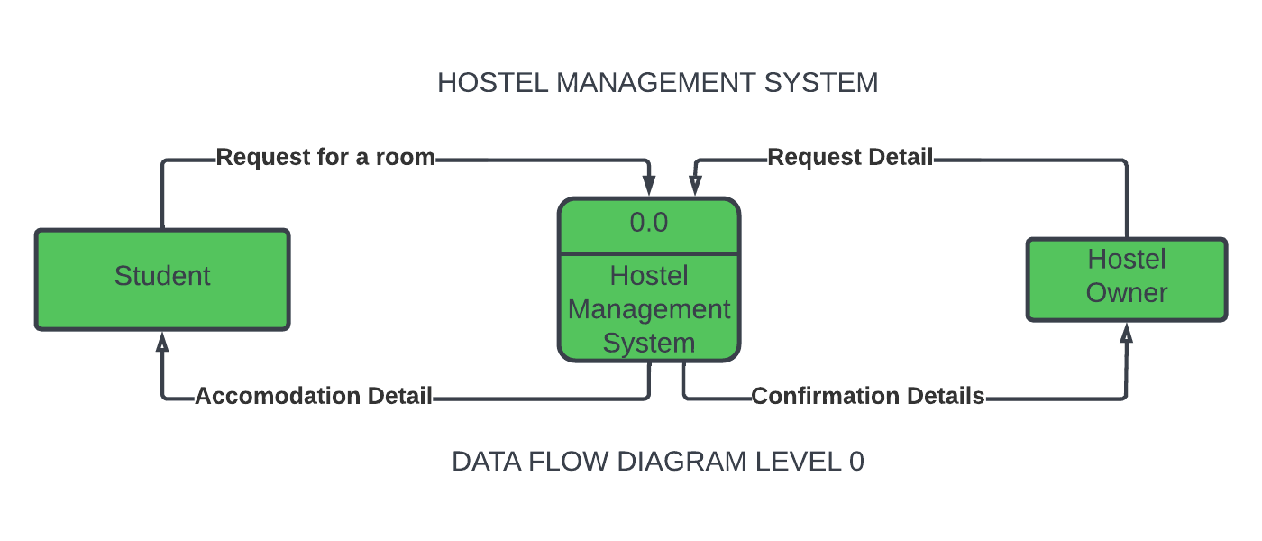

**2.3 ER DIAGRAM**

This diagram illustrates the Tables maintained in the Hostel management system.

There are three basic elements in an ER Diagram: entity,attribute,relationship.

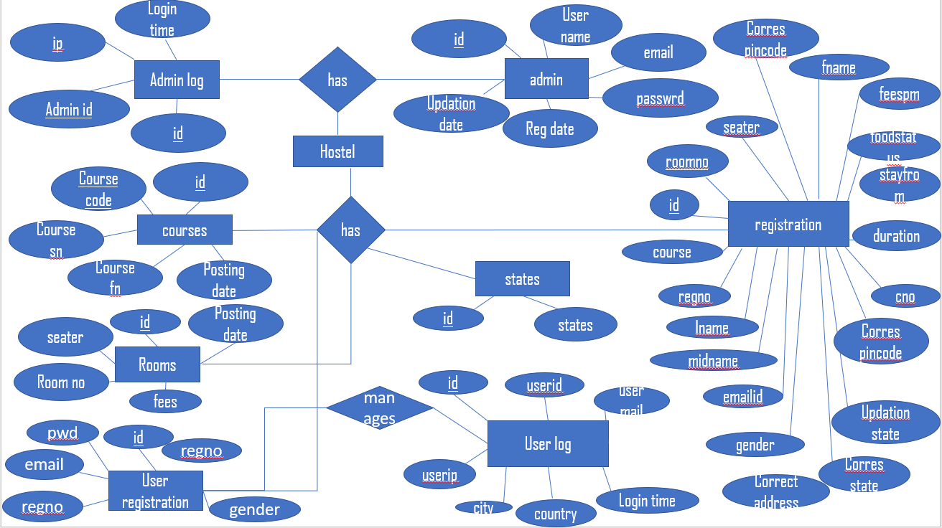

**CHAPTER 3**

**DATABASE DESIGN**

**TABLES:**

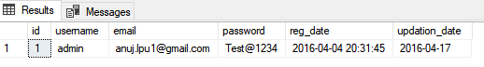

**Table 1: ADMIN**

The above table is the Admin table. It contains information about the admin. It contains the Id, username, email, password, reg date, updation date.This page is developed using HTML, CSS, Javascript and PHP to establish connection to the database . It fetches the information typed in that page and checks with the data stored in this table. If it matches it goes to the next page otherwise not.

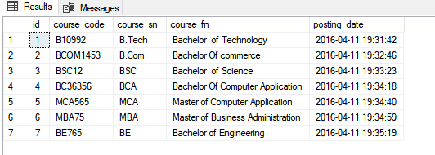

**Table 2: COURSES**

The above table is the Course table. It contains information about the courses. It contains the Id, course code, course sn, course fn , posting date. It fetches the information typed in that page and checks with the data stored in this table. It displays the courses available in that database and can select the courses which we needed.

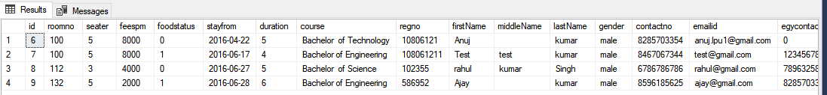

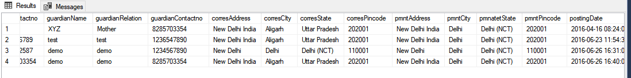



**Table 3:REGISTRATION**

The above table is the registration table. It contains information about the registered details. It contains the Id, room no, seater ,reg no, posting date etc...It fetches the information typed in that page and checks with the data stored in this table. It displays the registration details for the user in that database.

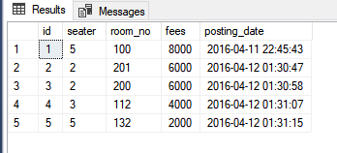

**Table 4: ROOMS**

The above table is the room table. It contains information about the room details. It contains the Id, room no ,seater, fees, posting date .It fetches the information typed in that page and checks with the data stored in this table. It displays the room details for the user to select according to their comfortable with seater in that database.

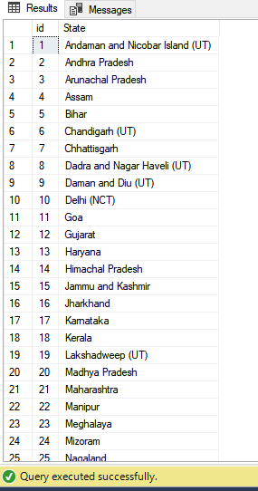

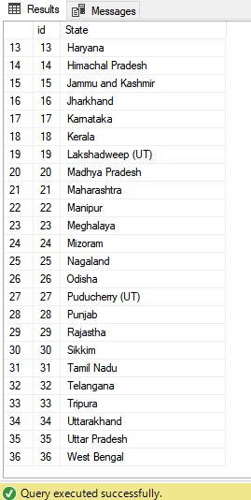

**Table 5: STATES**

The above table is the states table. It contains information about the states which is displayed. It contains the Id, states. It fetches the information typed in that page and checks with the data stored in this table. It displays the information about the states which are available for the user to select according to their states from where they are coming from in that database.

**CHAPTER 4**

**SOURCE CODE**

**PHP CODE**

**Add courses**

<?php

session_start();

include('includes/config.php');

include('includes/checklogin.php');

check_login();

//code for add courses

if($_POST['submit'])

{

$coursecode=$_POST['cc'];

$coursesn=$_POST['cns'];

$coursefn=$_POST['cnf'];

$query="insert into courses (course_code,course_sn,course_fn) values(?,?,?)";

$stmt = $mysqli->prepare($query);

$rc=$stmt->bind_param('sss',$coursecode,$coursesn,$coursefn);

$stmt->execute();

echo"<script>alert('Course has been added successfully');</script>";

}

?>

<!doctype html>

<html lang="en" class="no-js">

<head>

<meta charset="UTF-8">

<meta http-equiv="X-UA-Compatible" content="IE=edge">

<meta name="viewport" content="width=device-width, initial-scale=1, minimum-scale=1, maximum-scale=1">

<meta name="description" content="">

<meta name="author" content="">

<meta name="theme-color" content="#3e454c">

<title>Add Courses</title>

<link rel="stylesheet" href="css/font-awesome.min.css">

<link rel="stylesheet" href="css/bootstrap.min.css">

<link rel="stylesheet" href="css/dataTables.bootstrap.min.css">>

<link rel="stylesheet" href="css/bootstrap-social.css">

<link rel="stylesheet" href="css/bootstrap-select.css">

<link rel="stylesheet" href="css/fileinput.min.css">

<link rel="stylesheet" href="css/awesome-bootstrap-checkbox.css">

<link rel="stylesheet" href="css/style.css">

<script type="text/javascript" src="js/jquery-1.11.3-jquery.min.js"></script>

<script type="text/javascript" src="js/validation.min.js"></script>

</head>

<body>

<?php include('includes/header.php');?>

<div class="ts-main-content">

<?php include('includes/sidebar.php');?>

<div class="content-wrapper">

<div class="container-fluid">

<div class="row">

<div class="col-md-12">

<h2 class="page-title">Add Courses </h2>

<div class="row">

<div class="col-md-12">

<div class="panel panel-default">

<div class="panel-heading">Add courses</div>

<div class="panel-body">

<form method="post" class="form-horizontal">

<div class="hr-dashed"></div>

<div class="form-group">

<label class="col-sm-2 control-label">Course Code </label>

<div class="col-sm-8">

<input type="text" value="" name="cc" class="form-control"> </div>

</div>

<div class="form-group">

<label class="col-sm-2 control-label">Course Name (Short)</label>

<div class="col-sm-8">

<input type="text" class="form-control" name="cns" id="cns" value="" required="required">

</div>

</div>

<div class="form-group">

<label class="col-sm-2 control-label">Course Name(Full)</label>

<div class="col-sm-8">

<input type="text" class="form-control" name="cnf" value="" >

</div>

</div>

<div class="col-sm-8 col-sm-offset-2">

<input class="btn btn-primary" type="submit" name="submit" value="Add course">

</div>

</div>

</form>

</div>

</div>

</div>

</div>

</div>

</div>

</div>

</div>

</div>

</div>

<script src="js/jquery.min.js"></script>

<script src="js/bootstrap-select.min.js"></script>

<script src="js/bootstrap.min.js"></script>

<script src="js/jquery.dataTables.min.js"></script>

<script src="js/dataTables.bootstrap.min.js"></script>

<script src="js/Chart.min.js"></script>

<script src="js/fileinput.js"></script>

<script src="js/chartData.js"></script>

<script src="js/main.js"></script>

</script>

</body>

</html>

**Admin profile**

<?php

session_start();

include('includes/config.php');

include('includes/checklogin.php');

check_login();

//code for update email id

if($_POST['update'])

{

$email=$_POST['emailid'];

$aid=$_SESSION['id'];

$udate=date('Y-m-d');

$query="update admin set email=?,updation_date=? where id=?";

$stmt = $mysqli->prepare($query);

$rc=$stmt->bind_param('ssi',$email,$udate,$aid);

$stmt->execute();

echo"<script>alert('Email id has been successfully updated');</script>";

}

// code for change password

if(isset($_POST['changepwd']))

{

$op=$_POST['oldpassword'];

$np=$_POST['newpassword'];

$ai=$_SESSION['id'];

$udate=date('Y-m-d');

$sql="SELECT password FROM admin where password=?";

$chngpwd = $mysqli->prepare($sql);

$chngpwd->bind_param('s',$op);

$chngpwd->execute();

$chngpwd->store_result();

$row_cnt=$chngpwd->num_rows;;

if($row_cnt>0)

{

$con="update admin set password=?,updation_date=? where id=?";

$chngpwd1 = $mysqli->prepare($con);

$chngpwd1->bind_param('ssi',$np,$udate,$ai);

$chngpwd1->execute();

$_SESSION['msg']="Password Changed Successfully !!";

}

else

{

$_SESSION['msg']="Old Password not match !!";

}

}

?>

<!doctype html>

<html lang="en" class="no-js">

<head>

<meta charset="UTF-8">

<meta http-equiv="X-UA-Compatible" content="IE=edge">

<meta name="viewport" content="width=device-width, initial-scale=1, minimum-scale=1, maximum-scale=1">

<meta name="description" content="">

<meta name="author" content="">

<meta name="theme-color" content="#3e454c">

<title>Admin Profile</title>

<link rel="stylesheet" href="css/font-awesome.min.css">

<link rel="stylesheet" href="css/bootstrap.min.css">

<link rel="stylesheet" href="css/dataTables.bootstrap.min.css">>

<link rel="stylesheet" href="css/bootstrap-social.css">

<link rel="stylesheet" href="css/bootstrap-select.css">

<link rel="stylesheet" href="css/fileinput.min.css">

<link rel="stylesheet" href="css/awesome-bootstrap-checkbox.css">

<link rel="stylesheet" href="css/style.css">

<script type="text/javascript" src="js/jquery-1.11.3-jquery.min.js"></script>

<script type="text/javascript" src="js/validation.min.js"></script>

<script type="text/javascript">

function valid()

{

if(document.changepwd.newpassword.value!= document.changepwd.cpassword.value){

alert("Password and Re-Type Password Field do not match !!");

document.changepwd.cpassword.focus();

return false;

}

return true;

}

</script>

</head>

<body>

<?php include('includes/header.php');?>

<div class="ts-main-content">

<?php include('includes/sidebar.php');?>

<div class="content-wrapper">

<div class="container-fluid">

<div class="row">

<div class="col-md-12">

<h2 class="page-title">Admin Profile</h2>

<?php

$aid=$_SESSION['id'];

$ret="select * from admin where id=?";

$stmt= $mysqli->prepare($ret) ;

$stmt->bind_param('i',$aid);

$stmt->execute() ;//ok

$res=$stmt->get_result();

//$cnt=1;

while($row=$res->fetch_object()) {

?>

<div class="row">

<div class="col-md-6">

<div class="panel panel-default">

<div class="panel-heading">Admin profile details</div>

<div class="panel-body">

<form method="post" class="form-horizontal">

<div class="hr-dashed"></div>

<div class="form-group">

<label class="col-sm-2 control-label">Username </label>

<div class="col-sm-10">

<input type="text" value="<?php echo $row->username;?>" disabled class="form-control"><span class="help-block m-b-none">

Username can't be changed.</span> </div>

</div>

<div class="form-group">

<label class="col-sm-2 control-label">Email</label>

<div class="col-sm-10">

<input type="email" class="form-control" name="emailid" id="emailid" value="<?php echo $row->email;?>" required="required">

</div>

</div>

<div class="form-group">

<label class="col-sm-2 control-label">Reg Date</label>

<div class="col-sm-10">

<input type="text" class="form-control" value="<?php echo $row->reg_date;?>" disabled >

</div>

</div>

<div class="col-sm-8 col-sm-offset-2">

<button class="btn btn-default" type="submit">Cancel</button>

<input class="btn btn-primary" type="submit" name="update" value="Update Profile">

</div>

</div>

</form>

</div>

</div>

<?php }

?>

<div class="col-md-6">

<div class="panel panel-default">

<div class="panel-heading">Change Password</div>

<div class="panel-body">

<form method="post" class="form-horizontal" name="changepwd" id="change-pwd" onSubmit="return valid();">

<?php if(isset($_POST['changepwd']))

{ ?>

<p style="color: red"><?php echo htmlentities($_SESSION['msg']); ?><?php echo htmlentities($_SESSION['msg']=""); ?></p>

<?php } ?>

<div class="hr-dashed"></div>

<div class="form-group">

<label class="col-sm-4 control-label">old Password </label>

<div class="col-sm-8">

<input type="password" value="" name="oldpassword" id="oldpassword" class="form-control" onBlur="checkpass()" required="required">

<span id="password-availability-status" class="help-block m-b-none" style="font-size:12px;"></span> </div>

</div>

<div class="form-group">

<label class="col-sm-4 control-label">New Password</label>

<div class="col-sm-8">

<input type="password" class="form-control" name="newpassword" id="newpassword" value="" required="required">

</div>

</div>

<div class="form-group">

<label class="col-sm-4 control-label">Confirm Password</label>

<div class="col-sm-8">

<input type="password" class="form-control" value="" required="required" id="cpassword" name="cpassword" >

</div>

</div>

<div class="col-sm-6 col-sm-offset-4">

<button class="btn btn-default" type="submit">Cancel</button>

<input type="submit" name="changepwd" Value="Change Password" class="btn btn-primary">

</div>

</form>

</div> </div>

</div>

</div>

</div></div>

</div>

</div> </div>

</div>

</div>

<script src="js/jquery.min.js"></script>

<script src="js/bootstrap-select.min.js"></script>

<script src="js/bootstrap.min.js"></script>

<script src="js/jquery.dataTables.min.js"></script>

<script src="js/dataTables.bootstrap.min.js"></script>

<script src="js/Chart.min.js"></script>

<script src="js/fileinput.js"></script>

<script src="js/chartData.js"></script>

<script src="js/main.js"></script>

<script>

function checkAvailability() {

$("#loaderIcon").show();

jQuery.ajax({

url: "check_availability.php",

data:'emailid='+$("#emailid").val(),

type: "POST",

success:function(data){

$("#user-availability-status").html(data);

$("#loaderIcon").hide();

},

error:function (){}

});

}

</script>

<script>

function checkpass() {

$("#loaderIcon").show();

jQuery.ajax({

url: "check_availability.php",

data:'oldpassword='+$("#oldpassword").val(),

type: "POST",

success:function(data){

$("#password-availability-status").html(data);

$("#loaderIcon").hide();

},

error:function (){}

});

}

</script>

</body>

</html>

**Check availability**

<?php

session_start();

$aid=$_SESSION['id'];

require_once("includes/config.php");

if(!empty($_POST["roomno"]))

{

$roomno=$_POST["roomno"];

$result ="SELECT count(*) FROM registration WHERE roomno=?";

$stmt = $mysqli->prepare($result);

$stmt->bind_param('i',$roomno);

$stmt->execute();

$stmt->bind_result($count);

$stmt->fetch();

$stmt->close();

if($count>0)

echo "<span style='color:red'>$count. Seats already full.</span>";

else

echo "<span style='color:red'>All Seats are Available</span>";

}

if(!empty($_POST["oldpassword"]))

{

$pass=$_POST["oldpassword"];

$result ="SELECT password FROM userregistration WHERE password=?";

$stmt = $mysqli->prepare($result);

$stmt->bind_param('s',$pass);

$stmt->execute();

$stmt -> bind_result($result);

$stmt -> fetch();

$opass=$result;

if($opass==$pass)

echo "<span style='color:green'> Password matched .</span>";

else echo "<span style='color:red'> Password Not matched</span>";

}

?>

**Create room**

<?php

session_start();

include('includes/config.php');

include('includes/checklogin.php');

check_login();

//code for add courses

if($_POST['submit'])

{

$seater=$_POST['seater'];

$roomno=$_POST['rmno'];

$fees=$_POST['fee'];

$sql="SELECT room_no FROM rooms where room_no=?";

$stmt1 = $mysqli->prepare($sql);

$stmt1->bind_param('i',$roomno);

$stmt1->execute();

$stmt1->store_result();

$row_cnt=$stmt1->num_rows;;

if($row_cnt>0)

{

echo"<script>alert('Room alreadt exist');</script>";

}

else

{

$query="insert into rooms (seater,room_no,fees) values(?,?,?)";

$stmt = $mysqli->prepare($query);

$rc=$stmt->bind_param('iii',$seater,$roomno,$fees);

$stmt->execute();

echo"<script>alert('Room has been added successfully');</script>";

}

}

?>

<!doctype html>

<html lang="en" class="no-js">

<head>

<meta charset="UTF-8">

<meta http-equiv="X-UA-Compatible" content="IE=edge">

<meta name="viewport" content="width=device-width, initial-scale=1, minimum-scale=1, maximum-scale=1">

<meta name="description" content="">

<meta name="author" content="">

<meta name="theme-color" content="#3e454c">

<title>Create Room</title>

<link rel="stylesheet" href="css/font-awesome.min.css">

<link rel="stylesheet" href="css/bootstrap.min.css">

<link rel="stylesheet" href="css/dataTables.bootstrap.min.css">>

<link rel="stylesheet" href="css/bootstrap-social.css">

<link rel="stylesheet" href="css/bootstrap-select.css">

<link rel="stylesheet" href="css/fileinput.min.css">

<link rel="stylesheet" href="css/awesome-bootstrap-checkbox.css">

<link rel="stylesheet" href="css/style.css">

<script type="text/javascript" src="js/jquery-1.11.3-jquery.min.js"></script>

<script type="text/javascript" src="js/validation.min.js"></script>

</head>

<body>

<?php include('includes/header.php');?>

<div class="ts-main-content">

<?php include('includes/sidebar.php');?>

<div class="content-wrapper">

<div class="container-fluid">

<div class="row">

<div class="col-md-12">

<h2 class="page-title">Add a Room </h2>

<div class="row">

<div class="col-md-12">

<div class="panel panel-default">

<div class="panel-heading">Add a Room</div>

<div class="panel-body">

<?php if(isset($_POST['submit']))

{ ?>

<p style="color: red"><?php echo htmlentities($_SESSION['msg']); ?><?php echo htmlentities($_SESSION['msg']=""); ?></p>

<?php } ?>

<form method="post" class="form-horizontal">

<div class="hr-dashed"></div>

<div class="form-group">

<label class="col-sm-2 control-label">Select Seater </label>

<div class="col-sm-8">

<Select name="seater" class="form-control" required>

<option value="">Select Seater</option>

<option value="1">Single Seater</option>

<option value="2">Two Seater</option>

<option value="3">Three Seater</option>

<option value="4">Four Seater</option>

<option value="5">Five Seater</option>

</Select>

</div>

</div>

<div class="form-group">

<label class="col-sm-2 control-label">Room No.</label>

<div class="col-sm-8">

<input type="text" class="form-control" name="rmno" id="rmno" value="" required="required">

</div>

</div>

<div class="form-group">

<label class="col-sm-2 control-label">Fee(Per Student)</label>

<div class="col-sm-8">

<input type="text" class="form-control" name="fee" id="fee" value="" required="required">

</div>

</div>

<div class="col-sm-8 col-sm-offset-2">

<input class="btn btn-primary" type="submit" name="submit" value="Create Room ">

</div>

</div>

</form>

</div></div>

</div>

</div>

</div>

</div>

</div>

</div>

</div>

</div>

<script src="js/jquery.min.js"></script>

<script src="js/bootstrap-select.min.js"></script>

<script src="js/bootstrap.min.js"></script>

<script src="js/jquery.dataTables.min.js"></script>

<script src="js/dataTables.bootstrap.min.js"></script>

<script src="js/Chart.min.js"></script>

<script src="js/fileinput.js"></script>

<script src="js/chartData.js"></script>

<script src="js/main.js"></script>

</script>

</body>

</html>

**Dashboard**

<?php

session_start();

include('includes/config.php');

include('includes/checklogin.php');

check_login();?>

<!doctype html>

<html lang="en" class="no-js">

<head>

<meta charset="UTF-8">

<meta http-equiv="X-UA-Compatible" content="IE=edge">

<meta name="viewport" content="width=device-width, initial-scale=1, minimum-scale=1, maximum-scale=1">

<meta name="description" content="">

<meta name="author" content="">

<meta name="theme-color" content="#3e454c">

<title>DashBoard</title>

<link rel="stylesheet" href="css/font-awesome.min.css">

<link rel="stylesheet" href="css/bootstrap.min.css">

<link rel="stylesheet" href="css/dataTables.bootstrap.min.css">

<link rel="stylesheet" href="css/bootstrap-social.css">

<link rel="stylesheet" href="css/bootstrap-select.css">

<link rel="stylesheet" href="css/fileinput.min.css">

<link rel="stylesheet" href="css/awesome-bootstrap-checkbox.css">

<link rel="stylesheet" href="css/style.css">

</head>

<body>

<?php include("includes/header.php");?>

<div class="ts-main-content">

<?php include("includes/sidebar.php");?>

<div class="content-wrapper">

<div class="container-fluid">

<div class="row">

<div class="col-md-12">

<h2 class="page-title" style="margin-top:4%">Dashboard</h2>

<div class="row">

<div class="col-md-12">

<div class="row">

<div class="col-md-3">

<div class="panel panel-default">

<div class="panel-body bk-primary text-light">

<div class="stat-panel text-center">

<?php

$result ="SELECT count(*) FROM registration ";

$stmt = $mysqli->prepare($result);

$stmt->execute();

$stmt->bind_result($count);

$stmt->fetch();

$stmt->close();

?>

<div class="stat-panel-number h1 "><?php echo $count;?></div>

<div class="stat-panel-title text-uppercase"> Students</div>

</div>

</div>

<a href="manage-students.php" class="block-anchor panel-footer">Full Detail <i class="fa fa-arrow-right"></i></a>

</div>

</div>

<div class="col-md-3">

<div class="panel panel-default">

<div class="panel-body bk-success text-light">

<div class="stat-panel text-center">

<?php

$result1 ="SELECT count(*) FROM rooms ";

$stmt1 = $mysqli->prepare($result1);

$stmt1->execute();

$stmt1->bind_result($count1);

$stmt1->fetch();

$stmt1->close();

?>

<div class="stat-panel-number h1 "><?php echo $count1;?></div>

<div class="stat-panel-title text-uppercase">Total Rooms </div>

</div>

</div>

<a href="manage-rooms.php" class="block-anchor panel-footer text-center">See All &nbsp; <i class="fa fa-arrow-right"></i></a>

</div>

</div>

<div class="col-md-3">

<div class="panel panel-default">

<div class="panel-body bk-info text-light">

<div class="stat-panel text-center">

<?php

$result2 ="SELECT count(*) FROM courses ";

$stmt2 = $mysqli->prepare($result2);

$stmt2->execute();

$stmt2->bind_result($count2);

$stmt2->fetch();

$stmt2->close();

?>

<div class="stat-panel-number h1 "><?php echo $count2;?></div>

<div class="stat-panel-title text-uppercase">Total Courses</div>

</div>

</div>

<a href="manage-courses.php" class="block-anchor panel-footer text-center">See All &nbsp; <i class="fa fa-arrow-right"></i></a>

</div>

</div>

</div>

</div>

</div></div>

</div>

</div>

</div>

</div>

<!-- Loading Scripts -->

<script src="js/jquery.min.js"></script>

<script src="js/bootstrap-select.min.js"></script>

<script src="js/bootstrap.min.js"></script>

<script src="js/jquery.dataTables.min.js"></script>

<script src="js/dataTables.bootstrap.min.js"></script>

<script src="js/Chart.min.js"></script>

<script src="js/fileinput.js"></script>

<script src="js/chartData.js"></script>

<script src="js/main.js"></script>

<script>

window.onload = function(){

// Line chart from swirlData for dashReport

var ctx = document.getElementById("dashReport").getContext("2d");

window.myLine = new Chart(ctx).Line(swirlData, {

responsive: true,

scaleShowVerticalLines: false,

scaleBeginAtZero : true,

multiTooltipTemplate: "<%if (label){%><%=label%>: <%}%><%= value %>",

});

// Pie Chart from doughutData

var doctx = document.getElementById("chart-area3").getContext("2d");

window.myDoughnut = new Chart(doctx).Pie(doughnutData, {responsive : true});

// Dougnut Chart from doughnutData

var doctx = document.getElementById("chart-area4").getContext("2d");

window.myDoughnut = new Chart(doctx).Doughnut(doughnutData, {responsive : true});

} </script>

</body>

</html>

**Edit course**

<?php

session_start();

include('includes/config.php');

include('includes/checklogin.php');

check_login();

//code for add courses

if($_POST['submit'])

{

$coursecode=$_POST['cc'];

$coursesn=$_POST['cns'];

$coursefn=$_POST['cnf'];

$id=$_GET['id'];

$query="update courses set course_code=?,course_sn=?,course_fn=? where id=?";

$stmt = $mysqli->prepare($query);

$rc=$stmt->bind_param('sssi',$coursecode,$coursesn,$coursefn,$id);

$stmt->execute();

echo"<script>alert('Course has been Updated successfully');</script>";

}

?>

<!doctype html>

<html lang="en" class="no-js">

<head>

<meta charset="UTF-8">

<meta http-equiv="X-UA-Compatible" content="IE=edge">

<meta name="viewport" content="width=device-width, initial-scale=1, minimum-scale=1, maximum-scale=1">

<meta name="description" content="">

<meta name="author" content="">

<meta name="theme-color" content="#3e454c">

<title>Edit Course</title>

<link rel="stylesheet" href="css/font-awesome.min.css">

<link rel="stylesheet" href="css/bootstrap.min.css">

<link rel="stylesheet" href="css/dataTables.bootstrap.min.css">>

<link rel="stylesheet" href="css/bootstrap-social.css">

<link rel="stylesheet" href="css/bootstrap-select.css">

<link rel="stylesheet" href="css/fileinput.min.css">

<link rel="stylesheet" href="css/awesome-bootstrap-checkbox.css">

<link rel="stylesheet" href="css/style.css">

<script type="text/javascript" src="js/jquery-1.11.3-jquery.min.js"></script>

<script type="text/javascript" src="js/validation.min.js"></script>

</head>

<body>

<?php include('includes/header.php');?>

<div class="ts-main-content">

<?php include('includes/sidebar.php');?>

<div class="content-wrapper">

<div class="container-fluid">

<div class="row">

<div class="col-md-12">

<h2 class="page-title">Edit Course </h2>

<div class="row">

<div class="col-md-12">

<div class="panel panel-default">

<div class="panel-heading">Edit courses</div>

<div class="panel-body">

<form method="post" class="form-horizontal">

<?php

$id=$_GET['id'];

$ret="select * from courses where id=?";

$stmt= $mysqli->prepare($ret) ;

$stmt->bind_param('i',$id);

$stmt->execute() ;//ok

$res=$stmt->get_result();

//$cnt=1;

while($row=$res->fetch_object())

{

?>

<div class="hr-dashed"></div>

<div class="form-group">

<label class="col-sm-2 control-label">Course Code </label>

<div class="col-sm-8">

<input type="text" name="cc" value="<?php echo $row->course_code;?>" class="form-control"> </div>

</div>

<div class="form-group">

<label class="col-sm-2 control-label">Course Name (Short)</label>

<div class="col-sm-8">

<input type="text" class="form-control" name="cns" id="cns" value="<?php echo $row->course_sn;?>" required="required">

</div>

</div>

<div class="form-group">

<label class="col-sm-2 control-label">Course Name(Full)</label>

<div class="col-sm-8">

<input type="text" class="form-control" name="cnf" value="<?php echo $row->course_fn;?>" >

</div>

</div>

<?php } ?>

<div class="col-sm-8 col-sm-offset-2">

<input class="btn btn-primary" type="submit" name="submit" value="Update Course">

</div>

</div>

</form>

</div>

</div>

</div>

</div>

</div>

</div>

</div>

</div>

</div>

</div>

<script src="js/jquery.min.js"></script>

<script src="js/bootstrap-select.min.js"></script>

<script src="js/bootstrap.min.js"></script>

<script src="js/jquery.dataTables.min.js"></script>

<script src="js/dataTables.bootstrap.min.js"></script>

<script src="js/Chart.min.js"></script>

<script src="js/fileinput.js"></script>

<script src="js/chartData.js"></script>

<script src="js/main.js"></script>

</script>

</body>

</html>

**Edit room**

<?php

session_start();

include('includes/config.php');

include('includes/checklogin.php');

check_login();

//code for add courses

if($_POST['submit'])

{

$seater=$_POST['seater'];

$fees=$_POST['fees'];

$id=$_GET['id'];

$query="update rooms set seater=?,fees=? where id=?";

$stmt = $mysqli->prepare($query);

$rc=$stmt->bind_param('iii',$seater,$fees,$id);

$stmt->execute();

echo"<script>alert('Room Details has been Updated successfully');</script>";

}

?>

<!doctype html>

<html lang="en" class="no-js">

<head>

<meta charset="UTF-8">

<meta http-equiv="X-UA-Compatible" content="IE=edge">

<meta name="viewport" content="width=device-width, initial-scale=1, minimum-scale=1, maximum-scale=1">

<meta name="description" content="">

<meta name="author" content="">

<meta name="theme-color" content="#3e454c">

<title>Edit Room Details</title>

<link rel="stylesheet" href="css/font-awesome.min.css">

<link rel="stylesheet" href="css/bootstrap.min.css">

<link rel="stylesheet" href="css/dataTables.bootstrap.min.css">>

<link rel="stylesheet" href="css/bootstrap-social.css">

<link rel="stylesheet" href="css/bootstrap-select.css">

<link rel="stylesheet" href="css/fileinput.min.css">

<link rel="stylesheet" href="css/awesome-bootstrap-checkbox.css">

<link rel="stylesheet" href="css/style.css">

<script type="text/javascript" src="js/jquery-1.11.3-jquery.min.js"></script>

<script type="text/javascript" src="js/validation.min.js"></script>

</head>

<body>

<?php include('includes/header.php');?>

<div class="ts-main-content">

<?php include('includes/sidebar.php');?>

<div class="content-wrapper">

<div class="container-fluid">

<div class="row">

<div class="col-md-12">

<h2 class="page-title">Edit Room Details </h2>

<div class="row">

<div class="col-md-12">

<div class="panel panel-default">

<div class="panel-heading">Edit Room Details</div>

<div class="panel-body">

<form method="post" class="form-horizontal">

<?php

$id=$_GET['id'];

$ret="select * from rooms where id=?";

$stmt= $mysqli->prepare($ret) ;

$stmt->bind_param('i',$id);

$stmt->execute() ;//ok

$res=$stmt->get_result();

//$cnt=1;

while($row=$res->fetch_object())

{

?>

<div class="hr-dashed"></div>

<div class="form-group">

<label class="col-sm-2 control-label">Seater </label>

<div class="col-sm-8">

<input type="text" name="seater" value="<?php echo $row->seater;?>" class="form-control"> </div>

</div>

<div class="form-group">

<label class="col-sm-2 control-label">Room no </label>

<div class="col-sm-8">

<input type="text" class="form-control" name="rmno" id="rmno" value="<?php echo $row->room_no;?>" disabled>

<span class="help-block m-b-none">

Room no can't be changed.</span>

</div>

</div>

<div class="form-group">

<label class="col-sm-2 control-label">Fees (PM) </label>

<div class="col-sm-8">

<input type="text" class="form-control" name="fees" value="<?php echo $row->fees;?>" >

</div>

</div>

<?php } ?>

<div class="col-sm-8 col-sm-offset-2">

<input class="btn btn-primary" type="submit" name="submit" value="Update Room Details ">

</div></div>

</form>

</div>

</div></div>

</div>

</div>

</div>

</div>

</div></div>

</div>

<script src="js/jquery.min.js"></script>

<script src="js/bootstrap-select.min.js"></script>

<script src="js/bootstrap.min.js"></script>

<script src="js/jquery.dataTables.min.js"></script>

<script src="js/dataTables.bootstrap.min.js"></script>

<script src="js/Chart.min.js"></script>

<script src="js/fileinput.js"></script>

<script src="js/chartData.js"></script>

<script src="js/main.js"></script>

</script>

</body>

</html>

**Full Profile**

<?php

session_start();

define('DB_SERVER','localhost');

define('DB_USER','root');

define('DB_PASS' ,'');

define('DB_NAME', 'hostel');

$con = mysqli_connect(DB_SERVER,DB_USER,DB_PASS,DB_NAME);

// Check connection

if (mysqli_connect_errno())

{

echo "Failed to connect to MySQL: " . mysqli_connect_error();

}

?>

<script language="javascript" type="text/javascript">

function f2()

{

window.close();

}

function f3()

{

window.print();

}

</script>

<!DOCTYPE html PUBLIC "-//W3C//DTD XHTML 1.0 Transitional//EN" "http://www.w3.org/TR/xhtml1/DTD/xhtml1-transitional.dtd">

<html xmlns="http://www.w3.org/1999/xhtml">

<head>

<meta http-equiv="Content-Type" content="text/html; charset=iso-8859-1" />

<title>Student Information</title>

<link href="style.css" rel="stylesheet" type="text/css" />

<link href="hostel.css" rel="stylesheet" type="text/css">

</head>

<body>

<table width="100%" border="0">

<?php

$ret= mysqli_query($con,"SELECT * FROM registration where id = '".$_GET['id']."'");

while($row=mysqli_fetch_array($ret))

{

?>

<tr>

<td colspan="2" align="center" class="font1">&nbsp;</td>

</tr>

<tr>

<td colspan="2" align="center" class="font1">&nbsp;</td>

</tr><tr>

<td colspan="2" class="font"><?php echo ucfirst($row['firstName']);?> <?php echo ucfirst($row['lastName']);?>'S <span class="font1"> information &raquo;</span> </td>

</tr><tr>

<td colspan="2" class="font">&nbsp;&nbsp;&nbsp;&nbsp;&nbsp;&nbsp;&nbsp;&nbsp;&nbsp;&nbsp;&nbsp;&nbsp;

<div align="right">Reg Date : <span class="comb-value"><?php echo $row['postingDate'];?></span></div></td>

</tr>

<tr>

<td colspan="2" class="heading" style="color: red;">Room Related Info &raquo; </td>

</tr> <tr>

<td colspan="2" class="font1"><table width="100%" border="0">

<tr>

<td width="32%" valign="top" class="heading">Room no : </td>

<td class="comb-value1"><span class="comb-value"><?php echo $row['roomno'];?></span></td>

</tr>

<tr>

<td width="22%" valign="top" class="heading">Seater : </td>

<td class="comb-value1"><span class="comb-value"><?php echo $row['seater'];?></span></td>

</tr>

<tr>

<td width="12%" valign="top" class="heading">Fees PM : </td>

<td class="comb-value1"><?php echo $fpm=$row['feespm'];?></td>

</tr>

<tr>

<td width="12%" valign="top" class="heading">Food Status: </td>

<td class="comb-value1"><?php if($row['foodstatus']==0)

{

echo "Without Food";

}

else

{

echo "With Food";

}

;?></td>

</tr>

<tr>

<td width="12%" valign="top" class="heading">Staying From: </td>

<td class="comb-value1"><?php echo $row['stayfrom'];?></td>

</tr>

<tr>

<td width="12%" valign="top" class="heading">Duration: </td>

<td class="comb-value1"><?php echo $dr=$row['duration'];?></td>

</tr>

<tr>

<td width="12%" valign="top" class="heading">Total Fee: </td>

<td class="comb-value1">

<?php if($row['foodstatus']==1)

{

$fd=2000;

echo (($dr*$fpm)+$fd);

}

else

{

echo $dr*$fpm;

}

?></td>

</tr>

<tr>

<td colspan="2" align="left" class="heading" style="color: red;">Personal Info &raquo; </td>

</tr>

<tr>

<td width="12%" valign="top" class="heading">Course: </td>

<td class="comb-value1"><?php echo $row['course'];?></td>

</tr>

<tr>

<td width="12%" valign="top" class="heading">Reg no: </td>

<td class="comb-value1"><?php echo $row['regno'];?></td>

</tr>

<tr>

<td width="12%" valign="top" class="heading">First Name: </td>

<td class="comb-value1"><?php echo $row['firstName'];?></td>

</tr><tr>

<td width="12%" valign="top" class="heading">Middle name: </td>

<td class="comb-value1"><?php echo $row['middleName'];?></td>

</tr>

<tr>

<td width="12%" valign="top" class="heading">Last: </td>

<td class="comb-value1"><?php echo $row['lastName'];?></td>

</tr>

<tr>

<td width="12%" valign="top" class="heading">Gender: </td>

<td class="comb-value1"><?php echo $row['gender'];?></td>

</tr>

<tr>

<td width="12%" valign="top" class="heading">Contact No: </td>

<td class="comb-value1"><?php echo $row['contactno'];?></td>

</tr>

<tr>

<td width="12%" valign="top" class="heading">Email id: </td>

<td class="comb-value1"><?php echo $row['emailid'];?></td>

</tr>

<tr>

<td width="12%" valign="top" class="heading">Emergency Contact: </td>

<td class="comb-value1"><?php echo $row['egycontactno'];?></td>

</tr>

<tr>

<td width="12%" valign="top" class="heading">Guardian Name: </td>

<td class="comb-value1"><?php echo $row['guardianName'];?></td>

</tr>

<tr>

<td width="12%" valign="top" class="heading">Guardian Relation: </td>

<td class="comb-value1"><?php echo $row['guardianRelation'];?></td>

</tr>

<tr>

<td width="12%" valign="top" class="heading">Guardian Contact: </td>

<td class="comb-value1"><?php echo $row['guardianContactno'];?></td>

</tr>

<tr>

<td colspan="2" class="heading" style="color: red;">Correspondence Address &raquo; </td>

</tr>

<tr>

<td width="12%" valign="top" class="heading">Address: </td>

<td class="comb-value1"><?php echo $row['corresAddress'];?></td>

</tr>

<tr>

<td width="12%" valign="top" class="heading">City: </td>

<td class="comb-value1"><?php echo $row['corresCIty'];?></td>

</tr>

<tr>

<td width="12%" valign="top" class="heading">State: </td>

<td class="comb-value1"><?php echo $row['corresState'];?></td>

</tr>

<tr>

<td width="12%" valign="top" class="heading">Pincode: </td>

<td class="comb-value1"><?php echo $row['corresPincode'];?></td>

</tr>

<tr>

<td colspan="2" class="heading" style="color: red;">Permanent Address &raquo; </td>

</tr>

<tr>

<td width="12%" valign="top" class="heading">Address: </td>

<td class="comb-value1"><?php echo $row['pmntAddress'];?></td>

</tr>

<tr>

<td width="12%" valign="top" class="heading">City: </td>

<td class="comb-value1"><?php echo $row['pmntCity'];?></td>

</tr>

<tr>

<td width="12%" valign="top" class="heading">State: </td>

<td class="comb-value1"><?php echo $row['pmnatetState'];?></td>

</tr>

<tr>

<td width="12%" valign="top" class="heading">Pincode: </td>

<td class="comb-value1"><?php echo $row['pmntPincode'];?></td>

</tr>

<tr>

<td width="12%" valign="top" class="heading">State: </td>

<td class="comb-value1"><?php echo $row['pmnatetState'];?></td>

</tr>

<?php } ?>

</table></td>

</tr>

</table></td>

</tr>

</table></td>

</tr> </table></td>

</tr><tr>

<td colspan="2" align="right" ><form id="form1" name="form1" method="post" action="">

<table width="100%" border="0" cellpadding="0" cellspacing="0">

<tr>

<td width="14%">&nbsp;</td>

<td width="35%" class="comb-value"><label>

<input name="Submit" type="submit" class="txtbox4" value="Prints this Document " onClick="return f3();" />

</label></td>

<td width="3%">&nbsp;</td>

<td width="26%"><label>

<input name="Submit2" type="submit" class="txtbox4" value="Close this document " onClick="return f2();" />

</label></td>

<td width="8%">&nbsp;</td>

<td width="14%">&nbsp;</td>

</tr>

</table>

</form> </td>

</tr>

<tr>

<td colspan="2">&nbsp;</td>

</tr>

</table>

</body>

</html>

**Get seater**

<?php

include('includes/pdoconfig.php');

if(!empty($_POST["roomid"]))

{

$id=$_POST['roomid'];

$stmt = $DB_con->prepare("SELECT * FROM rooms WHERE room_no = :id");

$stmt->execute(array(':id' => $id));

?>

<?php

while($row=$stmt->fetch(PDO::FETCH_ASSOC))

{

?>

<?php echo htmlentities($row['seater']); ?>

<?php

}

}

if(!empty($_POST["rid"]))

{

$id=$_POST['rid'];

$stmt = $DB_con->prepare("SELECT * FROM rooms WHERE room_no = :id");

$stmt->execute(array(':id' => $id));

?>

<?php

while($row=$stmt->fetch(PDO::FETCH_ASSOC))

{

?>

<?php echo htmlentities($row['fees']); ?>

<?php

}}

?>

**Index**

<?php

session_start();

include('includes/config.php');

if(isset($_POST['login']))

{

$username=$_POST['username'];

$password=$_POST['password'];

$stmt=$mysqli->prepare("SELECT username,email,password,id FROM admin WHERE (userName=?|| email=?) and password=? ");

$stmt->bind_param('sss',$username,$username,$password);

$stmt->execute();

$stmt -> bind_result($username,$username,$password,$id);

$rs=$stmt->fetch();

$_SESSION['id']=$id;

$uip=$_SERVER['REMOTE_ADDR'];

$ldate=date('d/m/Y h:i:s', time());

if($rs)

{

// $insert="INSERT into admin(adminid,ip)VALUES(?,?)";

// $stmtins = $mysqli->prepare($insert);

// $stmtins->bind_param('sH',$id,$uip);

//$res=$stmtins->execute();

header("location:admin-profile.php");

}

else

{

echo "<script>alert('Invalid Username/Email or password');</script>";

}

}

?>

<!doctype html>

<html lang="en" class="no-js">

<head>

<meta charset="UTF-8">

<meta http-equiv="X-UA-Compatible" content="IE=edge">

<meta name="viewport" content="width=device-width, initial-scale=1, minimum-scale=1, maximum-scale=1">

<meta name="description" content="">

<meta name="author" content="">

<title>Admin login</title>

<link rel="stylesheet" href="css/font-awesome.min.css">

<link rel="stylesheet" href="css/bootstrap.min.css">

<link rel="stylesheet" href="css/dataTables.bootstrap.min.css">

<link rel="stylesheet" href="css/bootstrap-social.css">

<link rel="stylesheet" href="css/bootstrap-select.css">

<link rel="stylesheet" href="css/fileinput.min.css">

<link rel="stylesheet" href="css/awesome-bootstrap-checkbox.css">

<link rel="stylesheet" href="css/style.css">

</head

<body>

<div class="login-page bk-img" style="background-image: url(img/login-bg.jpg);">

<div class="form-content">

<div class="container">

<div class="row">

<div class="col-md-6 col-md-offset-3" style="margin-top:4%">

<h1 class="text-center text-bold text-light mt-4x">Hostel Management System</h1>

<div class="well row pt-2x pb-3x bk-light">

<div class="col-md-8 col-md-offset-2">

<form action="" class="mt" method="post">

<label for="" class="text-uppercase text-sm">Your Username or Email</label

<input type="text" placeholder="Username" name="username" class="form-control mb">

<label for="" class="text-uppercase text-sm">Password</label>

<input type="password" placeholder="Password" name="password" class="form-control mb">

<input type="submit" name="login" class="btn btn-primary btn-block" value="login" >

</form>

</div>

</div>

</div>

</div>

</div>

</div>

</div>

<script src="js/jquery.min.js"></script>

<script src="js/bootstrap-select.min.js"></script>

<script src="js/bootstrap.min.js"></script>

<script src="js/jquery.dataTables.min.js"></script>

<script src="js/dataTables.bootstrap.min.js"></script>

<script src="js/Chart.min.js"></script>

<script src="js/fileinput.js"></script>

<script src="js/chartData.js"></script>

<script src="js/main.js"></script>

</body>

</html>

**Logout**

<?php

session_start();

unset($_SESSION['id']);

session_destroy();

header('Location:../index.php');

?>

**Manage course**

<?php

session_start();

include('includes/config.php');

include('includes/checklogin.php');

check_login();

if(isset($_GET['del']))

{

$id=intval($_GET['del']);

$adn="delete from courses where id=?";

$stmt= $mysqli->prepare($adn);

$stmt->bind_param('i',$id);

$stmt->execute();

$stmt->close();

echo "<script>alert('Data Deleted');</script>" ;}

?>

<!doctype html>

<html lang="en" class="no-js">

<head>

<meta charset="UTF-8">

<meta http-equiv="X-UA-Compatible" content="IE=edge">

<meta name="viewport" content="width=device-width, initial-scale=1, minimum-scale=1, maximum-scale=1">

<meta name="description" content="">

<meta name="author" content="">

<meta name="theme-color" content="#3e454c">

<title>Manage Courses</title>

<link rel="stylesheet" href="css/font-awesome.min.css">

<link rel="stylesheet" href="css/bootstrap.min.css">

<link rel="stylesheet" href="css/dataTables.bootstrap.min.css">

<link rel="stylesheet" href="css/bootstrap-social.css">

<link rel="stylesheet" href="css/bootstrap-select.css">

<link rel="stylesheet" href="css/fileinput.min.css">

<link rel="stylesheet" href="css/awesome-bootstrap-checkbox.css">

<link rel="stylesheet" href="css/style.css">

</head>

<body>

<?php include('includes/header.php');?>

<div class="ts-main-content">

<?php include('includes/sidebar.php');?>

<div class="content-wrapper">

<div class="container-fluid">

<div class="row">

<div class="col-md-12">

<h2 class="page-title" style="margin-top:4%">Manage Course</h2>

<div class="panel panel-default">

<div class="panel-heading">All Courses Details</div>

<div class="panel-body">

<table id="zctb" class="display table table-striped table-bordered table-hover" cellspacing="0" width="100%">

<thead>

<tr>

<th>Sno.</th>

<th>Course Code</th>

<th>Course Name(Short)</th>

<th>Course Name(Full)</th>

<th>Reg Date </th>

<th>Action</th>

</tr>

</thead>

<tfoot><tr>

<th>Sl No</th>

<th>Course Code</th>

<th>Course Name(Short)</th>

<th>Course Name(Full)</th>

<th>Regd Date</th>

<th>Action</th></tr>

</tfoot>

<tbody>

<?php

$aid=$_SESSION['id'];

$ret="select * from courses";

$stmt= $mysqli->prepare($ret) ;

//$stmt->bind_param('i',$aid);

$stmt->execute() ;//ok

$res=$stmt->get_result();

$cnt=1;

while($row=$res->fetch_object()){?>

<tr><td><?php echo $cnt;;?></td>

<td><?php echo $row->course_code;?></td>

<td><?php echo $row->course_sn;?></td>

<td><?php echo $row->course_fn;?></td>

<td><?php echo $row->posting_date;?></td>

<td><a href="edit-course.php?id=<?php echo $row->id;?>"><i class="fa fa-edit"></i></a>&nbsp;&nbsp;

<a href="manage-courses.php?del=<?php echo $row->id;?>" onclick="return confirm("Do you want to delete");"><i class="fa fa-close"></i></a></td>

</tr>

<?php

$cnt=$cnt+1;

} ?>

</tbody>

</table>

</div>

</div>

</div>

</div>

</div>

</div>

</div>

<!-- Loading Scripts -->

<script src="js/jquery.min.js"></script>

<script src="js/bootstrap-select.min.js"></script>

<script src="js/bootstrap.min.js"></script>

<script src="js/jquery.dataTables.min.js"></script>

<script src="js/dataTables.bootstrap.min.js"></script>

<script src="js/Chart.min.js"></script>

<script src="js/fileinput.js"></script>

<script src="js/chartData.js"></script>

<script src="js/main.js"></script>

</body>

</html>

**Manage rooms**

<?php

session_start();

include('includes/config.php');

include('includes/checklogin.php');

check_login();

if(isset($_GET['del']))

{

$id=intval($_GET['del']);

$adn="delete from rooms where id=?";

$stmt= $mysqli->prepare($adn);

$stmt->bind_param('i',$id);

$stmt->execute();

$stmt->close();

echo "<script>alert('Data Deleted');</script>" ;

}

?>

<!doctype html>

<html lang="en" class="no-js">

<head>

<meta charset="UTF-8">

<meta http-equiv="X-UA-Compatible" content="IE=edge">

<meta name="viewport" content="width=device-width, initial-scale=1, minimum-scale=1, maximum-scale=1">

<meta name="description" content="">

<meta name="author" content="">

<meta name="theme-color" content="#3e454c">

<title>Manage Rooms</title>

<link rel="stylesheet" href="css/font-awesome.min.css">

<link rel="stylesheet" href="css/bootstrap.min.css">

<link rel="stylesheet" href="css/dataTables.bootstrap.min.css">

<link rel="stylesheet" href="css/bootstrap-social.css">

<link rel="stylesheet" href="css/bootstrap-select.css">

<link rel="stylesheet" href="css/fileinput.min.css">

<link rel="stylesheet" href="css/awesome-bootstrap-checkbox.css">

<link rel="stylesheet" href="css/style.css">

</head>

<body>

<?php include('includes/header.php');?>

<div class="ts-main-content">

<?php include('includes/sidebar.php');?>

<div class="content-wrapper">

<div class="container-fluid">

<div class="row">

<div class="col-md-12">

<h2 class="page-title" style="margin-top: 4%">Manage Rooms</h2>

<div class="panel panel-default">

<div class="panel-heading">All Room Details</div>

<div class="panel-body">

<table id="zctb" class="display table table-striped table-bordered table-hover" cellspacing="0" width="100%">

<thead>

<tr>

<th>Sno.</th>

<th>Seater</th>

<th>Room No.</th> <th>Fees (PM) </th>

<th>Posting Date </th>

<th>Action</th>

</tr>

</thead>

<tfoot>

<tr>

<th>Sno.</th> <th>Seater</th>

<th>Room No.</th>

<th>Fees (PM) </th>

<th>Posting Date </th>

<th>Action</th>

</tr>

</tfoot>

<tbody>

<?php

$aid=$_SESSION['id'];

$ret="select * from rooms";

$stmt= $mysqli->prepare($ret) ;

//$stmt->bind_param('i',$aid);

$stmt->execute() ;//ok

$res=$stmt->get_result();

$cnt=1;

while($row=$res->fetch_object())

{

?>

<tr><td><?php echo $cnt;;?></td>

<td><?php echo $row->seater;?></td>

<td><?php echo $row->room_no;?></td>

<td><?php echo $row->fees;?></td>

<td><?php echo $row->posting_date;?></td>

<td><a href="edit-room.php?id=<?php echo $row->id;?>"><i class="fa fa-edit"></i></a>&nbsp;&nbsp;

<a href="manage-rooms.php?del=<?php echo $row->id;?>" onclick="return confirm("Do you want to delete");"><i class="fa fa-close"></i></a></td>

</tr>

<?php

$cnt=$cnt+1;

} ?>

</tbody>

</table>

</div>

</div>

</div>

</div>

</div>

</div>

</div>

<!-- Loading Scripts -->

<script src="js/jquery.min.js"></script>

<script src="js/bootstrap-select.min.js"></script>

<script src="js/bootstrap.min.js"></script>

<script src="js/jquery.dataTables.min.js"></script>

<script src="js/dataTables.bootstrap.min.js"></script>

<script src="js/Chart.min.js"></script>

<script src="js/fileinput.js"></script>

<script src="js/chartData.js"></script>

<script src="js/main.js"></script>

</body>

</html>

**Manage students**

<?php

session_start();

include('includes/config.php');

include('includes/checklogin.php');

check_login();

if(isset($_GET['del']))

{

$id=intval($_GET['del']);

$adn="delete from registration where id=?";

$stmt= $mysqli->prepare($adn);

$stmt->bind_param('i',$id);

$stmt->execute();

$stmt->close();

echo "<script>alert('Data Deleted');</script>" ;

}

?>

<!doctype html>

<html lang="en" class="no-js">

<head>

<meta charset="UTF-8">

<meta http-equiv="X-UA-Compatible" content="IE=edge">

<meta name="viewport" content="width=device-width, initial-scale=1, minimum-scale=1, maximum-scale=1">

<meta name="description" content="">

<meta name="author" content="">

<meta name="theme-color" content="#3e454c">

<title>Manage Rooms</title>

<link rel="stylesheet" href="css/font-awesome.min.css">

<link rel="stylesheet" href="css/bootstrap.min.css">

<link rel="stylesheet" href="css/dataTables.bootstrap.min.css">

<link rel="stylesheet" href="css/bootstrap-social.css">

<link rel="stylesheet" href="css/bootstrap-select.css">

<link rel="stylesheet" href="css/fileinput.min.css">

<link rel="stylesheet" href="css/awesome-bootstrap-checkbox.css">

<link rel="stylesheet" href="css/style.css">

<script language="javascript" type="text/javascript">

var popUpWin=0;

function popUpWindow(URLStr, left, top, width, height)

{

if(popUpWin)

{

if(!popUpWin.closed) popUpWin.close();

}

popUpWin = open(URLStr,'popUpWin', 'toolbar=no,location=no,directories=no,status=no,menubar=no,scrollbars=yes,resizable=no,copyhistory=yes,width='+510+',height='+430+',left='+left+', top='+top+',screenX='+left+',screenY='+top+'');

}

</script>

</head>

<body>

<?php include('includes/header.php');?>

<div class="ts-main-content">

<?php include('includes/sidebar.php');?>

<div class="content-wrapper">

<div class="container-fluid">

<div class="row">

<div class="col-md-12">

<h2 class="page-title" style="margin-top:4%">Manage Registred Students</h2>

<div class="panel panel-default">

<div class="panel-heading">All Room Details</div><div class="panel-body">

<table id="zctb" class="display table table-striped table-bordered table-hover" cellspacing="0" width="100%">

<thead>

<tr><th>Sno.</th>

<th>Student Name</th>

<th>Reg no</th>

<th>Contact no </th>

<th>room no </th>

<th>Seater </th>

<th>Staying From </th>

<th>Action</th>

</tr>

</thead>

<tfoot>

<tr>

<th>Sno.</th>

<th>Student Name</th>

<th>Reg no</th>

<th>Contact no </th>

<th>Room no </th>

<th>Seater </th>

<th>Staying From </th>

<th>Action</th>

</tr>

</tfoot>

<tbody>

<?php

$aid=$_SESSION['id'];

$ret="select * from registration";

$stmt= $mysqli->prepare($ret) ;

//$stmt->bind_param('i',$aid);

$stmt->execute() ;//ok

$res=$stmt->get_result();

$cnt=1;

while($row=$res->fetch_object())

{

?>

<tr><td><?php echo $cnt;;?></td>

<td><?php echo $row->firstName;?><?php echo $row->middleName;?><?php echo $row->lastName;?></td>

<td><?php echo $row->regno;?></td>

<td><?php echo $row->contactno;?></td>

<td><?php echo $row->roomno;?></td>

<td><?php echo $row->seater;?></td>

<td><?php echo $row->stayfrom;?></td>

<td>

<a href="javascript:void(0);" onClick="popUpWindow('http://localhost/hostel/admin/full-profile.php?id=<?php echo $row->id;?>');" title="View Full Details"><i class="fa fa-desktop"></i></a>&nbsp;&nbsp;

<a href="manage-students.php?del=<?php echo $row->id;?>" title="Delete Record" onclick="return confirm("Do you want to delete");"><i class="fa fa-close"></i></a></td>

</tr>

<?php

$cnt=$cnt+1;

} ?>

</tbody>

</table>

</div>

</div>

</div>

</div>

</div>

</div>

</div>

<!-- Loading Scripts -->

<script src="js/jquery.min.js"></script>

<script src="js/bootstrap-select.min.js"></script>

<script src="js/bootstrap.min.js"></script>

<script src="js/jquery.dataTables.min.js"></script>

<script src="js/dataTables.bootstrap.min.js"></script>

<script src="js/Chart.min.js"></script>

<script src="js/fileinput.js"></script>

<script src="js/chartData.js"></script>

<script src="js/main.js"></script>

</body>

</html>

**Registration**

<?php

session_start();

include('includes/config.php');

include('includes/checklogin.php');

check_login();

//code for registration

if($_POST['submit'])

{

$roomno=$_POST['room'];

$seater=$_POST['seater'];

$feespm=$_POST['fpm'];

$foodstatus=$_POST['foodstatus'];

$stayfrom=$_POST['stayf'];

$duration=$_POST['duration'];

$course=$_POST['course'];

$regno=$_POST['regno'];

$fname=$_POST['fname'];

$mname=$_POST['mname'];

$lname=$_POST['lname'];

$gender=$_POST['gender'];

$contactno=$_POST['contact'];

$emailid=$_POST['email'];

$emcntno=$_POST['econtact'];

$gurname=$_POST['gname'];

$gurrelation=$_POST['grelation'];

$gurcntno=$_POST['gcontact'];

$caddress=$_POST['address'];

$ccity=$_POST['city'];

$cstate=$_POST['state'];

$cpincode=$_POST['pincode'];

$paddress=$_POST['paddress'];

$pcity=$_POST['pcity'];

$pstate=$_POST['pstate'];

$ppincode=$_POST['ppincode'];

$query="insert into registration(roomno,seater,feespm,foodstatus,stayfrom,duration,course,regno,firstName,middleName,lastName,gender,contactno,emailid,egycontactno,guardianName,guardianRelation,guardianContactno,corresAddress,corresCIty,corresState,corresPincode,pmntAddress,pmntCity,pmnatetState,pmntPincode) values(?,?,?,?,?,?,?,?,?,?,?,?,?,?,?,?,?,?,?,?,?,?,?,?,?,?)";

$stmt = $mysqli->prepare($query);

$rc=$stmt->bind_param('iiiisisissssisississsisssi',$roomno,$seater,$feespm,$foodstatus,$stayfrom,$duration,$course,$regno,$fname,$mname,$lname,$gender,$contactno,$emailid,$emcntno,$gurname,$gurrelation,$gurcntno,$caddress,$ccity,$cstate,$cpincode,$paddress,$pcity,$pstate,$ppincode);

$stmt->execute();

$stmt->close();

$query1="insert into userregistration(regNo,firstName,middleName,lastName,gender,contactNo,email,password) values(?,?,?,?,?,?,?,?)";

$stmt1= $mysqli->prepare($query1);

$stmt1->bind_param('sssssiss',$regno,$fname,$mname,$lname,$gender,$contactno,$emailid,$contactno);

$stmt1->execute();

echo"<script>alert('Student Succssfully register');</script>";

}?>

<!doctype html>

<html lang="en" class="no-js">

<head>

<meta charset="UTF-8">

<meta http-equiv="X-UA-Compatible" content="IE=edge">

<meta name="viewport" content="width=device-width, initial-scale=1, minimum-scale=1, maximum-scale=1">

<meta name="description" content="">

<meta name="author" content="">

<meta name="theme-color" content="#3e454c">

<title>Student Hostel Registration</title>

<link rel="stylesheet" href="css/font-awesome.min.css">

<link rel="stylesheet" href="css/bootstrap.min.css">

<link rel="stylesheet" href="css/dataTables.bootstrap.min.css">>

<link rel="stylesheet" href="css/bootstrap-social.css">

<link rel="stylesheet" href="css/bootstrap-select.css">

<link rel="stylesheet" href="css/fileinput.min.css">

<link rel="stylesheet" href="css/awesome-bootstrap-checkbox.css">

<link rel="stylesheet" href="css/style.css">

<script type="text/javascript" src="js/jquery-1.11.3-jquery.min.js"></script>

<script type="text/javascript" src="js/validation.min.js"></script>

<script type="text/javascript" src="http://code.jquery.com/jquery.min.js"></script>

<script>

function getSeater(val) {

$.ajax({

type: "POST",

url: "get_seater.php",

data:'roomid='+val,

success: function(data){

//alert(data);

$('#seater').val(data);

}

});

$.ajax({

type: "POST",

url: "get_seater.php",

data:'rid='+val,

success: function(data){

//alert(data);

$('#fpm').val(data);

}

});

}

</script>

</head>

<body>

<?php include('includes/header.php');?>

<div class="ts-main-content">

<?php include('includes/sidebar.php');?>

<div class="content-wrapper">

<div class="container-fluid">

<div class="row">

<div class="col-md-12">

<h2 class="page-title">Registration </h2>

<div class="row">

<div class="col-md-12">

<div class="panel panel-primary">

<div class="panel-heading">Fill all Info</div>

<div class="panel-body">

<form method="post" action="" class="form-horizontal">

<div class="form-group">

<label class="col-sm-4 control-label"><h4 style="color: green" align="left">Room Related info </h4> </label>

</div>

<div class="form-group">

<label class="col-sm-2 control-label">Room no. </label>

<div class="col-sm-8">

<select name="room" id="room"class="form-control" onChange="getSeater(this.value);" onBlur="checkAvailability()" required>

<option value="">Select Room</option>

<?php $query ="SELECT * FROM rooms";

$stmt2 = $mysqli->prepare($query);

$stmt2->execute();

$res=$stmt2->get_result();

while($row=$res->fetch_object())

{

?>

<option value="<?php echo $row->room_no;?>"> <?php echo $row->room_no;?></option>

<?php } ?>

</select>

<span id="room-availability-status" style="font-size:12px;"></span>

</div>

</div>

<div class="form-group">

<label class="col-sm-2 control-label">Seater</label>

<div class="col-sm-8">

<input type="text" name="seater" id="seater" class="form-control" >

</div>

</div>

<div class="form-group">

<label class="col-sm-2 control-label">Fees Per Month</label>

<div class="col-sm-8">

<input type="text" name="fpm" id="fpm" class="form-control" >

</div>

</div>

<div class="form-group">

<label class="col-sm-2 control-label">Food Status</label>

<div class="col-sm-8">

<input type="radio" value="0" name="foodstatus" checked="checked"> Without Food

<input type="radio" value="1" name="foodstatus"> With Food(Rs 2000.00 Per Month Extra)

</div>

</div>

<div class="form-group">

<label class="col-sm-2 control-label">Stay From</label>

<div class="col-sm-8">

<input type="date" name="stayf" id="stayf" class="form-control" >

</div>

</div>

<div class="form-group">

<label class="col-sm-2 control-label">Duration</label>

<div class="col-sm-8">

<select name="duration" id="duration" class="form-control">

<option value="">Select Duration in Month</option>

<option value="1">1</option>

<option value="2">2</option>

<option value="3">3</option>

<option value="4">4</option>

<option value="5">5</option>

<option value="6">6</option>

<option value="7">7</option>

<option value="8">8</option>

<option value="9">9</option>

<option value="10">10</option>

<option value="11">11</option>

<option value="12">12</option>

</select>

</div>

</div>

<div class="form-group">

<label class="col-sm-2 control-label"><h4 style="color: green" align="left">Personal info </h4> </label>

</div>

<div class="form-group">

<label class="col-sm-2 control-label">course </label>

<div class="col-sm-8">

<select name="course" id="course" class="form-control" required>

<option value="">Select Course</option>

<?php $query ="SELECT * FROM courses";

$stmt2 = $mysqli->prepare($query);

$stmt2->execute();

$res=$stmt2->get_result();

while($row=$res->fetch_object())

{

?>

<option value="<?php echo $row->course_fn;?>"><?php echo $row->course_fn;?>&nbsp;&nbsp;(<?php echo $row->course_sn;?>)</option>

<?php } ?>

</select> </div>

</div>

<div class="form-group">

<label class="col-sm-2 control-label">Registration No : </label>

<div class="col-sm-8">

<input type="text" name="regno" id="regno" class="form-control" required="required" >

</div>

</div>

<div class="form-group">

<label class="col-sm-2 control-label">First Name : </label>

<div class="col-sm-8">

<input type="text" name="fname" id="fname" class="form-control" required="required" >

</div>

</div>

<div class="form-group">

<label class="col-sm-2 control-label">Middle Name : </label>

<div class="col-sm-8">

<input type="text" name="mname" id="mname" class="form-control">

</div>

</div>

<div class="form-group">

<label class="col-sm-2 control-label">Last Name : </label>

<div class="col-sm-8">

<input type="text" name="lname" id="lname" class="form-control" required="required">

</div>

</div>

<div class="form-group">

<label class="col-sm-2 control-label">Gender : </label>

<div class="col-sm-8">

<select name="gender" class="form-control" required="required">

<option value="">Select Gender</option>

<option value="male">Male</option>

<option value="female">Female</option>

<option value="others">Others</option>

</select>

</div>

</div>

<div class="form-group">

<label class="col-sm-2 control-label">Contact No : </label>

<div class="col-sm-8">

<input type="text" name="contact" id="contact" class="form-control" required="required">

</div>

</div>

<div class="form-group">

<label class="col-sm-2 control-label">Email id : </label>

<div class="col-sm-8">

<input type="email" name="email" id="email" class="form-control" required="required">

</div>

</div>

<div class="form-group">

<label class="col-sm-2 control-label">Emergency Contact: </label>

<div class="col-sm-8">

<input type="text" name="econtact" id="econtact" class="form-control" required="required">

</div>

</div>

<div class="form-group">

<label class="col-sm-2 control-label">Guardian Name : </label>

<div class="col-sm-8">

<input type="text" name="gname" id="gname" class="form-control" required="required">

</div>

</div>

<div class="form-group">

<label class="col-sm-2 control-label">Guardian Relation : </label>

<div class="col-sm-8">

<input type="text" name="grelation" id="grelation" class="form-control" required="required">

</div>

</div>

<div class="form-group">

<label class="col-sm-2 control-label">Guardian Contact no : </label>

<div class="col-sm-8">

<input type="text" name="gcontact" id="gcontact" class="form-control" required="required">

</div>

</div>

<div class="form-group">

<label class="col-sm-3 control-label"><h4 style="color: green" align="left">Correspondense Address </h4> </label>

</div>

<div class="form-group">

<label class="col-sm-2 control-label">Address : </label>

<div class="col-sm-8">

<textarea rows="5" name="address" id="address" class="form-control" required="required"></textarea>

</div>

</div>

<div class="form-group">

<label class="col-sm-2 control-label">City : </label>

<div class="col-sm-8">

<input type="text" name="city" id="city" class="form-control" required="required">

</div>

</div>

<div class="form-group">

<label class="col-sm-2 control-label">State </label>

<div class="col-sm-8">

<select name="state" id="state"class="form-control" required>

<option value="">Select State</option>

<?php $query ="SELECT * FROM states";

$stmt2 = $mysqli->prepare($query);

$stmt2->execute();

$res=$stmt2->get_result();

while($row=$res->fetch_object())

{

?>

<option value="<?php echo $row->State;?>"><?php echo $row->State;?></option>

<?php } ?>

</select> </div>

</div>

<div class="form-group">

<label class="col-sm-2 control-label">Pincode : </label>

<div class="col-sm-8">

<input type="text" name="pincode" id="pincode" class="form-control" required="required">

</div>

</div>

<div class="form-group">

<label class="col-sm-3 control-label"><h4 style="color: green" align="left">Permanent Address </h4> </label>

</div>

<div class="form-group">

<label class="col-sm-5 control-label">Permanent Address same as Correspondense address : </label>

<div class="col-sm-4">

<input type="checkbox" name="adcheck" value="1"/>

</div>

</div>

<div class="form-group">

<label class="col-sm-2 control-label">Address : </label>

<div class="col-sm-8">

<textarea rows="5" name="paddress" id="paddress" class="form-control" required="required"></textarea>

</div>

</div>

<div class="form-group">

<label class="col-sm-2 control-label">City : </label>

<div class="col-sm-8">

<input type="text" name="pcity" id="pcity" class="form-control" required="required">

</div>

</div>

<div class="form-group">

<label class="col-sm-2 control-label">State </label>

<div class="col-sm-8">

<select name="pstate" id="pstate"class="form-control" required>

<option value="">Select State</option>

<?php $query ="SELECT * FROM states";

$stmt2 = $mysqli->prepare($query);

$stmt2->execute();

$res=$stmt2->get_result();

while($row=$res->fetch_object())

{

?>

<option value="<?php echo $row->State;?>"><?php echo $row->State;?></option>

<?php } ?>

</select> </div>

</div>

<div class="form-group">

<label class="col-sm-2 control-label">Pincode : </label>

<div class="col-sm-8">

<input type="text" name="ppincode" id="ppincode" class="form-control" required="required">

</div>

</div>

<div class="col-sm-6 col-sm-offset-4">

<button class="btn btn-default" type="submit">Cancel</button>

<input type="submit" name="submit" Value="Register" class="btn btn-primary">

</div>

</form>

</div>

</div>

</div>

</div>

</div>

</div>

</div>

</div>

</div>

</div>

</div>

</div>

<script src="js/jquery.min.js"></script>

<script src="js/bootstrap-select.min.js"></script>

<script src="js/bootstrap.min.js"></script>

<script src="js/jquery.dataTables.min.js"></script>

<script src="js/dataTables.bootstrap.min.js"></script>

<script src="js/Chart.min.js"></script>

<script src="js/fileinput.js"></script>

<script src="js/chartData.js"></script>

<script src="js/main.js"></script>

</body>

<script type="text/javascript">

$(document).ready(function(){

$('input[type="checkbox"]').click(function(){

if($(this).prop("checked") == true){

$('#paddress').val( $('#address').val() );

$('#pcity').val( $('#city').val() );

$('#pstate').val( $('#state').val() );

$('#ppincode').val( $('#pincode').val() );

}

});

});

</script>

<script>

function checkAvailability() {

$("#loaderIcon").show();

jQuery.ajax({

url: "check_availability.php",

data:'roomno='+$("#room").val(),

type: "POST",

success:function(data){

$("#room-availability-status").html(data);

$("#loaderIcon").hide();

},

error:function (){}

});

}

</script>

</html>

**Book hostel**

<?php

session_start();

include('includes/config.php');

include('includes/checklogin.php');

check_login();

//code for registration

if(isset($_POST['submit']))

{

$roomno=$_POST['room'];

$seater=$_POST['seater'];

$feespm=$_POST['fpm'];

$foodstatus=$_POST['foodstatus'];

$stayfrom=$_POST['stayf'];

$duration=$_POST['duration'];

$course=$_POST['course'];

$regno=$_POST['regno'];

$fname=$_POST['fname'];

$mname=$_POST['mname'];

$lname=$_POST['lname'];

$gender=$_POST['gender'];

$contactno=$_POST['contact'];

$emailid=$_POST['email'];

$emcntno=$_POST['econtact'];

$gurname=$_POST['gname'];

$gurrelation=$_POST['grelation'];

$gurcntno=$_POST['gcontact'];

$caddress=$_POST['address'];

$ccity=$_POST['city'];

$cstate=$_POST['state'];

$cpincode=$_POST['pincode'];

$paddress=$_POST['paddress'];

$pcity=$_POST['pcity'];

$pstate=$_POST['pstate'];

$ppincode=$_POST['ppincode'];

$query="insert into registration(roomno,seater,feespm,foodstatus,stayfrom,duration,course,regno,firstName,middleName,lastName,gender,contactno,emailid,egycontactno,guardianName,guardianRelation,guardianContactno,corresAddress,corresCIty,corresState,corresPincode,pmntAddress,pmntCity,pmnatetState,pmntPincode) values(?,?,?,?,?,?,?,?,?,?,?,?,?,?,?,?,?,?,?,?,?,?,?,?,?,?)";

$stmt = $mysqli->prepare($query);

$rc=$stmt->bind_param('iiiisisissssisississsisssi',$roomno,$seater,$feespm,$foodstatus,$stayfrom,$duration,$course,$regno,$fname,$mname,$lname,$gender,$contactno,$emailid,$emcntno,$gurname,$gurrelation,$gurcntno,$caddress,$ccity,$cstate,$cpincode,$paddress,$pcity,$pstate,$ppincode);

$stmt->execute();

echo"<script>alert('Student Succssfully register');</script>";

}

?>

<!doctype html>

<html lang="en" class="no-js">

<head>

<meta charset="UTF-8">

<meta http-equiv="X-UA-Compatible" content="IE=edge">

<meta name="viewport" content="width=device-width, initial-scale=1, minimum-scale=1, maximum-scale=1">

<meta name="description" content="">

<meta name="author" content="">

<meta name="theme-color" content="#3e454c">

<title>Student Hostel Registration</title>

<link rel="stylesheet" href="css/font-awesome.min.css">

<link rel="stylesheet" href="css/bootstrap.min.css">

<link rel="stylesheet" href="css/dataTables.bootstrap.min.css">>

<link rel="stylesheet" href="css/bootstrap-social.css">

<link rel="stylesheet" href="css/bootstrap-select.css">

<link rel="stylesheet" href="css/fileinput.min.css">

<link rel="stylesheet" href="css/awesome-bootstrap-checkbox.css">

<link rel="stylesheet" href="css/style.css">

<script type="text/javascript" src="js/jquery-1.11.3-jquery.min.js"></script>

<script type="text/javascript" src="js/validation.min.js"></script>

<script type="text/javascript" src="http://code.jquery.com/jquery.min.js"></script>

<script>

function getSeater(val) {

$.ajax({

type: "POST",

url: "get_seater.php",

data:'roomid='+val,

success: function(data){

//alert(data);

$('#seater').val(data);

}

});

$.ajax({

type: "POST",

url: "get_seater.php",

data:'rid='+val,

success: function(data){

//alert(data);

$('#fpm').val(data);

}

});

}

</script>

</head>

<body>

<?php include('includes/header.php');?>

<div class="ts-main-content">

<?php include('includes/sidebar.php');?>

<div class="content-wrapper">

<div class="container-fluid">

<div class="row">

<div class="col-md-12">

<h2 class="page-title">Registration </h2>

<div class="row">

<div class="col-md-12">

<div class="panel panel-primary">

<div class="panel-heading">Fill all Info</div>

<div class="panel-body">

<form method="post" action="" class="form-horizontal">

<?php

$uid=$_SESSION['login'];

$stmt=$mysqli->prepare("SELECT emailid FROM registration WHERE emailid=? ");

$stmt->bind_param('s',$uid);

$stmt->execute();

$stmt -> bind_result($email);

$rs=$stmt->fetch();

$stmt->close();

if($rs)

{ ?>

<h3 style="color: red" align="left">Hostel already booked by you</h3>

<?php }

else{

echo "";

}

?>

<div class="form-group">

<label class="col-sm-4 control-label"><h4 style="color: green" align="left">Room Related info </h4> </label>

</div>

<div class="form-group">

<label class="col-sm-2 control-label">Room no. </label>

<div class="col-sm-8">

<select name="room" id="room"class="form-control" onChange="getSeater(this.value);" onBlur="checkAvailability()" required>

<option value="">Select Room</option>

<?php $query ="SELECT * FROM rooms";

$stmt2 = $mysqli->prepare($query);

$stmt2->execute();

$res=$stmt2->get_result();

while($row=$res->fetch_object())

{

?>

<option value="<?php echo $row->room_no;?>"> <?php echo $row->room_no;?></option>

<?php } ?>

</select>

<span id="room-availability-status" style="font-size:12px;"></span>

</div>

</div>

<div class="form-group">

<label class="col-sm-2 control-label">Seater</label>

<div class="col-sm-8">

<input type="text" name="seater" id="seater" class="form-control" >

</div>

</div>

<div class="form-group">

<label class="col-sm-2 control-label">Fees Per Month</label>

<div class="col-sm-8">

<input type="text" name="fpm" id="fpm" class="form-control" >

</div>

</div>

<div class="form-group">

<label class="col-sm-2 control-label">Food Status</label>

<div class="col-sm-8">

<input type="radio" value="0" name="foodstatus" checked="checked"> Without Food

<input type="radio" value="1" name="foodstatus"> With Food(Rs 2000.00 Per Month Extra)

</div>

</div>

<div class="form-group">

<label class="col-sm-2 control-label">Stay From</label>

<div class="col-sm-8">

<input type="date" name="stayf" id="stayf" class="form-control" >

</div>

</div>

<div class="form-group">

<label class="col-sm-2 control-label">Duration</label>

<div class="col-sm-8">

<select name="duration" id="duration" class="form-control">

<option value="">Select Duration in Month</option>

<option value="1">1</option>

<option value="2">2</option>

<option value="3">3</option>

<option value="4">4</option>

<option value="5">5</option>

<option value="6">6</option>

<option value="7">7</option>

<option value="8">8</option>

<option value="9">9</option>

<option value="10">10</option>

<option value="11">11</option>

<option value="12">12</option>

</select>

</div>

</div>

<div class="form-group">

<label class="col-sm-2 control-label">Total Amount</label>

<div class="col-sm-8">

<input type="text" name="ta" id="ta" class="result form-control" >

</div>

</div>

<div class="form-group">

<label class="col-sm-2 control-label"><h4 style="color: green" align="left">Personal info </h4> </label>

</div>

<div class="form-group">

<label class="col-sm-2 control-label">course </label>

<div class="col-sm-8">

<select name="course" id="course" class="form-control" required>

<option value="">Select Course</option>

<?php $query ="SELECT * FROM courses";

$stmt2 = $mysqli->prepare($query);

$stmt2->execute();

$res=$stmt2->get_result();

while($row=$res->fetch_object())

{

?>

<option value="<?php echo $row->course_fn;?>"><?php echo $row->course_fn;?>&nbsp;&nbsp;(<?php echo $row->course_sn;?>)</option>

<?php } ?>

</select> </div>

</div>

<?php

$aid=$_SESSION['id'];

$ret="select * from userregistration where id=?";

$stmt= $mysqli->prepare($ret) ;

$stmt->bind_param('i',$aid);

$stmt->execute() ;//ok

$res=$stmt->get_result();

//$cnt=1;

while($row=$res->fetch_object())

{?>

<div class="form-group">

<label class="col-sm-2 control-label">Registration No : </label>

<div class="col-sm-8">

<input type="text" name="regno" id="regno" class="form-control" value="<?php echo $row->regNo;?>" readonly >

</div>

</div>

<div class="form-group">

<label class="col-sm-2 control-label">First Name : </label>

<div class="col-sm-8">

<input type="text" name="fname" id="fname" class="form-control" value="<?php echo $row->firstName;?>" readonly>

</div>

</div>

<div class="form-group">

<label class="col-sm-2 control-label">Middle Name : </label>

<div class="col-sm-8">

<input type="text" name="mname" id="mname" class="form-control" value="<?php echo $row->middleName;?>" readonly>

</div>

</div>

<div class="form-group">

<label class="col-sm-2 control-label">Last Name : </label>

<div class="col-sm-8">

<input type="text" name="lname" id="lname" class="form-control" value="<?php echo $row->lastName;?>" readonly>

</div>

</div>

<div class="form-group">

<label class="col-sm-2 control-label">Gender : </label>

<div class="col-sm-8">

<input type="text" name="gender" value="<?php echo $row->gender;?>" class="form-control" readonly>

</div>

</div>

<div class="form-group">

<label class="col-sm-2 control-label">Contact No : </label>

<div class="col-sm-8">

<input type="text" name="contact" id="contact" value="<?php echo $row->contactNo;?>" class="form-control" readonly>

</div>

</div>

<div class="form-group">

<label class="col-sm-2 control-label">Email id : </label>

<div class="col-sm-8">

<input type="email" name="email" id="email" class="form-control" value="<?php echo $row->email;?>" readonly>

</div>

</div>

<?php } ?>

<div class="form-group">

<label class="col-sm-2 control-label">Emergency Contact: </label>

<div class="col-sm-8">

<input type="text" name="econtact" id="econtact" class="form-control" required="required">

</div>

</div>

<div class="form-group">

<label class="col-sm-2 control-label">Guardian Name : </label>

<div class="col-sm-8">

<input type="text" name="gname" id="gname" class="form-control" required="required">

</div></div>

<div class="form-group">

<label class="col-sm-2 control-label">Guardian Relation : </label>

<div class="col-sm-8">

<input type="text" name="grelation" id="grelation" class="form-control" required="required">

</div>

</div>

<div class="form-group">

<label class="col-sm-2 control-label">Guardian Contact no : </label>

<div class="col-sm-8">

<input type="text" name="gcontact" id="gcontact" class="form-control" required="required">

</div>

</div>

<div class="form-group">

<label class="col-sm-3 control-label"><h4 style="color: green" align="left">Correspondense Address </h4> </label>

</div>

<div class="form-group">

<label class="col-sm-2 control-label">Address : </label>

<div class="col-sm-8">

<textarea rows="5" name="address" id="address" class="form-control" required="required"></textarea>

</div>

</div>

<div class="form-group">

<label class="col-sm-2 control-label">City : </label>

<div class="col-sm-8">

<input type="text" name="city" id="city" class="form-control" required="required">

</div>

</div>

<div class="form-group">

<label class="col-sm-2 control-label">State </label>

<div class="col-sm-8">

<select name="state" id="state"class="form-control" required>

<option value="">Select State</option>

<?php $query ="SELECT * FROM states";

$stmt2 = $mysqli->prepare($query);

$stmt2->execute();

$res=$stmt2->get_result();

while($row=$res->fetch_object())

{

?>

<option value="<?php echo $row->State;?>"><?php echo $row->State;?></option>

<?php } ?>

</select> </div>

</div>

<div class="form-group">

<label class="col-sm-2 control-label">Pincode : </label>

<div class="col-sm-8">

<input type="text" name="pincode" id="pincode" class="form-control" required="required">

</div>

</div>

<div class="form-group">

<label class="col-sm-3 control-label"><h4 style="color: green" align="left">Permanent Address </h4> </label>

</div>

<div class="form-group">

<label class="col-sm-5 control-label">Permanent Address same as Correspondense address : </label>

<div class="col-sm-4">

<input type="checkbox" name="adcheck" value="1"/>

</div>

</div>

<div class="form-group">

<label class="col-sm-2 control-label">Address : </label>

<div class="col-sm-8">

<textarea rows="5" name="paddress" id="paddress" class="form-control" required="required"></textarea>

</div>

</div>

<div class="form-group">

<label class="col-sm-2 control-label">City : </label>

<div class="col-sm-8">

<input type="text" name="pcity" id="pcity" class="form-control" required="required">

</div>

</div>

<div class="form-group">

<label class="col-sm-2 control-label">State </label>

<div class="col-sm-8">

<select name="pstate" id="pstate"class="form-control" required>

<option value="">Select State</option>

<?php $query ="SELECT * FROM states";

$stmt2 = $mysqli->prepare($query);

$stmt2->execute();

$res=$stmt2->get_result();

while($row=$res->fetch_object())

{

?>

<option value="<?php echo $row->State;?>"><?php echo $row->State;?></option>

<?php } ?>

</select> </div>

</div>

<div class="form-group">

<label class="col-sm-2 control-label">Pincode : </label>

<div class="col-sm-8">

<input type="text" name="ppincode" id="ppincode" class="form-control" required="required">

</div>

</div>

<div class="col-sm-6 col-sm-offset-4">

<button class="btn btn-default" type="submit">Cancel</button>

<input type="submit" name="submit" Value="Register" class="btn btn-primary">

</div>

</form>

</div>

</div>

</div>

</div>

</div>

</div>

</div>

</div>

</div>

</div>

</div>

</div>

<script src="js/jquery.min.js"></script>

<script src="js/bootstrap-select.min.js"></script>

<script src="js/bootstrap.min.js"></script>

<script src="js/jquery.dataTables.min.js"></script>

<script src="js/dataTables.bootstrap.min.js"></script>

<script src="js/Chart.min.js"></script>

<script src="js/fileinput.js"></script>

<script src="js/chartData.js"></script>

<script src="js/main.js"></script>

</body>

<script type="text/javascript">

$(document).ready(function(){

$('input[type="checkbox"]').click(function(){

if($(this).prop("checked") == true){

$('#paddress').val( $('#address').val() );

$('#pcity').val( $('#city').val() );

$('#pstate').val( $('#state').val() );

$('#ppincode').val( $('#pincode').val() );

}

});

});

</script>

<script>

function checkAvailability() {

$("#loaderIcon").show();

jQuery.ajax({

url: "check_availability.php",

data:'roomno='+$("#room").val(),

type: "POST",

success:function(data){

$("#room-availability-status").html(data);

$("#loaderIcon").hide();

},

error:function (){}

});

}

</script>

<script type="text/javascript">

$(document).ready(function() {

$('#duration').keyup(function(){

var fetch_dbid = $(this).val();

$.ajax({

type:'POST',

url :"ins-amt.php?action=userid",

data :{userinfo:fetch_dbid},

success:function(data){

$('.result').val(data);

}

});

})});

</script>

</html>

**Change password**

<?php

session_start();

include('includes/config.php');

date_default_timezone_set('Asia/Kolkata');

include('includes/checklogin.php');

check_login();

$ai=$_SESSION['id'];

if(isset($_POST['changepwd'])){

$op=$_POST['oldpassword'];

$np=$_POST['newpassword'];

$udate=date('d-m-Y h:i:s', time());;

$sql="SELECT password FROM userregistration where password=?";

$chngpwd = $mysqli->prepare($sql);

$chngpwd->bind_param('s',$op);

$chngpwd->execute();

$chngpwd->store_result();

$row_cnt=$chngpwd->num_rows;;

if($row_cnt>0)

{

$con="update userregistration set password=?,passUdateDate=? where id=?";

$chngpwd1 = $mysqli->prepare($con);

$chngpwd1->bind_param('ssi',$np,$udate,$ai);

$chngpwd1->execute();

$_SESSION['msg']="Password Changed Successfully !!";

}

else

{

$_SESSION['msg']="Old Password not match !!";

}

}

?>

<!doctype html>

<html lang="en" class="no-js">

<head>

<meta charset="UTF-8">

<meta http-equiv="X-UA-Compatible" content="IE=edge">

<meta name="viewport" content="width=device-width, initial-scale=1, minimum-scale=1, maximum-scale=1">

<meta name="description" content="">

<meta name="author" content="">

<meta name="theme-color" content="#3e454c">

<title>Change Password</title>

<link rel="stylesheet" href="css/font-awesome.min.css">

<link rel="stylesheet" href="css/bootstrap.min.css">

<link rel="stylesheet" href="css/dataTables.bootstrap.min.css">>

<link rel="stylesheet" href="css/bootstrap-social.css">

<link rel="stylesheet" href="css/bootstrap-select.css">

<link rel="stylesheet" href="css/fileinput.min.css">

<link rel="stylesheet" href="css/awesome-bootstrap-checkbox.css">

<link rel="stylesheet" href="css/style.css">

<script type="text/javascript" src="js/jquery-1.11.3-jquery.min.js"></script>

<script type="text/javascript" src="js/validation.min.js"></script>

<script type="text/javascript">

function valid()

{

if(document.changepwd.newpassword.value!= document.changepwd.cpassword.value)

{

alert("Password and Re-Type Password Field do not match !!");

document.changepwd.cpassword.focus();

return false;

}

return true;

}

</script>

</head>

<body>

<?php include('includes/header.php');?>

<div class="ts-main-content">

<?php include('includes/sidebar.php');?>

<div class="content-wrapper">

<div class="container-fluid">

<div class="row">

<div class="col-md-12">

<h2 class="page-title">Change Password </h2>

<div class="row">

<div class="col-md-10">

<div class="panel panel-default">

<div class="panel-heading">

<?php $result ="SELECT passUdateDate FROM userregistration WHERE id=?";

$stmt = $mysqli->prepare($result);

$stmt->bind_param('i',$ai);

$stmt->execute();

$stmt -> bind_result($result);

$stmt -> fetch(); ?>

Last Updation Date:&nbsp;<?php echo $result; ?> </div>

<div class="panel-body">

<form method="post" class="form-horizontal" name="changepwd" id="change-pwd" onSubmit="return valid();">

<?php if(isset($_POST['changepwd']))

{ ?>

<pstyle="color: red"><?php echo htmlentities($_SESSION['msg']); ?><?php echo htmlentities($_SESSION['msg']=""); ?></p>

<?php } ?>

<div class="hr-dashed"></div>

<div class="form-group">

<label class="col-sm-4 control-label">old Password </label>

<div class="col-sm-8">

<input type="password" value="" name="oldpassword" id="oldpassword" class="form-control" onBlur="checkpass()" required="required">

<span id="password-availability-status" class="help-block m-b-none" style="font-size:12px;"></span> </div>

</div>

<div class="form-group">

<label class="col-sm-4 control-label">New Password</label>

<div class="col-sm-8">

<input type="password" class="form-control" name="newpassword" id="newpassword" value="" required="required">

</div>

</div>

<div class="form-group">

<label class="col-sm-4 control-label">Confirm Password</label>

<div class="col-sm-8">

<input type="password" class="form-control" value="" required="required" id="cpassword" name="cpassword" >

</div>

</div>

<div class="col-sm-6 col-sm-offset-4">

<button class="btn btn-default" type="submit">Cancel</button>

<input type="submit" name="changepwd" Value="Change Password" class="btn btn-primary">

</div>

</form>

</div>

</div>

</div>

</div>

</div>

</div>

</div>

</div>

</div>

</div>

</div>

<script src="js/jquery.min.js"></script>

<script src="js/bootstrap-select.min.js"></script>

<script src="js/bootstrap.min.js"></script>

<script src="js/jquery.dataTables.min.js"></script>

<script src="js/dataTables.bootstrap.min.js"></script>

<script src="js/Chart.min.js"></script>

<script src="js/fileinput.js"></script>

<script src="js/chartData.js"></script>

<script src="js/main.js"></script>

<script>

function checkpass() {

$("#loaderIcon").show();

jQuery.ajax({

url: "check_availability.php",

data:'oldpassword='+$("#oldpassword").val(),

type: "POST",

success:function(data){

$("#password-availability-status").html(data);

$("#loaderIcon").hide();

},

error:function (){}

});

}

</script>

</body>

</html>

**Forgot password**

<?php

session_start();

include('includes/config.php');

if(isset($_POST['login']))

{

$email=$_POST['email'];

$contact=$_POST['contact'];

$stmt=$mysqli->prepare("SELECT email,contactNo,password FROM userregistration WHERE (email=? && contactNo=?) ");

$stmt->bind_param('ss',$email,$contact);

$stmt->execute();

$stmt -> bind_result($username,$email,$password);

$rs=$stmt->fetch();

if($rs)

{

$pwd=$password;

}else

{

echo "<script>alert('Invalid Email/Contact no or password');</script>";

}

}

?>

<!doctype html>

<html lang="en" class="no-js">

<head>

<meta charset="UTF-8">

<meta http-equiv="X-UA-Compatible" content="IE=edge">

<meta name="viewport" content="width=device-width, initial-scale=1, minimum-scale=1, maximum-scale=1">

<meta name="description" content="">

<meta name="author" content="">

<title>User Forgot Password</title>

<link rel="stylesheet" href="css/font-awesome.min.css">

<link rel="stylesheet" href="css/bootstrap.min.css">

<link rel="stylesheet" href="css/dataTables.bootstrap.min.css">

<link rel="stylesheet" href="css/bootstrap-social.css">

<link rel="stylesheet" href="css/bootstrap-select.css">

<link rel="stylesheet" href="css/fileinput.min.css">

<link rel="stylesheet" href="css/awesome-bootstrap-checkbox.css">

<link rel="stylesheet" href="css/style.css">

</head

<body>

<div class="login-page bk-img" style="background-image: url(img/login-bg.jpg);">

<div class="form-content">

<div class="container">

<div class="row">

<div class="col-md-6 col-md-offset-3">

<h1 class="text-center text-bold text-light mt-4x">Forgot Password</h1>

<div class="well row pt-2x pb-3x bk-light">

<div class="col-md-8 col-md-offset-2">

<?php if(isset($_POST['login']))

{ ?>

<p>Yuor Password is <?php echo $pwd;?><br> Change the Password After login</p>

<?php } ?>

<form action="" class="mt" method="post">

<label for="" class="text-uppercase text-sm">Your Email</label>

<input type="email" placeholder="Email" name="email" class="form-control mb">

<label for="" class="text-uppercase text-sm">Your Contact no</label>

<input type="text" placeholder="Contact no" name="contact" class="form-control mb">

<input type="submit" name="login" class="btn btn-primary btn-block" value="login" >

</form>

</div>

</div>

<div class="text-center text-light">

<a href="index.php" class="text-light">Sign in?</a>

</div>

</div>

</div>

</div>

</div>

</div>

<script src="js/jquery.min.js"></script>

<script src="js/bootstrap-select.min.js"></script>

<script src="js/bootstrap.min.js"></script>

<script src="js/jquery.dataTables.min.js"></script>

<script src="js/dataTables.bootstrap.min.js"></script>

<script src="js/Chart.min.js"></script>

<script src="js/fileinput.js"></script>

<script src="js/chartData.js"></script>

<script src="js/main.js"></script>

</body>

</html>

**Login**

<?php

session_start();

include('includes/config.php');

if(isset($_POST['login']))

{

$email=$_POST['email'];

$password=$_POST['password'];

$stmt=$mysqli->prepare("SELECT email,password,id FROM userregistration WHERE email=? and password=? ");

$stmt->bind_param('ss',$email,$password);

$stmt->execute();

$stmt -> bind_result($email,$password,$id);

$rs=$stmt->fetch();

$stmt->close();

$_SESSION['id']=$id;

$_SESSION['login']=$email;

$uip=$_SERVER['REMOTE_ADDR'];

$ldate=date('d/m/Y h:i:s', time());

if($rs){

$uid=$_SESSION['id'];

$uemail=$_SESSION['login'];

$ip=$_SERVER['REMOTE_ADDR'];

$geopluginURL='http://www.geoplugin.net/php.gp?ip='.$ip;

$addrDetailsArr = unserialize(file_get_contents($geopluginURL));

$city = $addrDetailsArr['geoplugin_city'];

$country = $addrDetailsArr['geoplugin_countryName'];

$log="insert into userLog(userId,userEmail,userIp,city,country) values('$uid','$uemail','$ip','$city','$country')";

$mysqli->query($log);

if($log)

{

header("location:dashboard.php");

}

}

else

{

echo "<script>alert('Invalid Username/Email or password');</script>";

}

}

?>

<!doctype html>

<html lang="en" class="no-js">

<head>

<meta charset="UTF-8">

<meta http-equiv="X-UA-Compatible" content="IE=edge">

<meta name="viewport" content="width=device-width, initial-scale=1, minimum-scale=1, maximum-scale=1">

<meta name="description" content="">

<meta name="author" content="">

<meta name="theme-color" content="#3e454c">

<title>Student Hostel Registration</title>

<link rel="stylesheet" href="css/font-awesome.min.css">

<link rel="stylesheet" href="css/bootstrap.min.css">

<link rel="stylesheet" href="css/dataTables.bootstrap.min.css">>

<link rel="stylesheet" href="css/bootstrap-social.css">

<link rel="stylesheet" href="css/bootstrap-select.css">

<link rel="stylesheet" href="css/fileinput.min.css">

<link rel="stylesheet" href="css/awesome-bootstrap-checkbox.css">

<link rel="stylesheet" href="css/style.css">

<script type="text/javascript" src="js/jquery-1.11.3-jquery.min.js"></script>

<script type="text/javascript" src="js/validation.min.js"></script>

<script type="text/javascript" src="http://code.jquery.com/jquery.min.js"></script>

<script type="text/javascript">

function valid()

{

if(document.registration.password.value!= document.registration.cpassword.value)

{

alert("Password and Re-Type Password Field do not match !!");

document.registration.cpassword.focus();

return false;

}

return true;

}

</script>

</head>

<body>

<?php include('includes/header.php');?>

<div class="ts-main-content">

<?php include('includes/sidebar.php');?>

<div class="content-wrapper">

<div class="container-fluid">

<div class="row">

div class="col-md-12">

<h2 class="page-title">User Login </h2>

<div class="row">

<div class="col-md-6 col-md-offset-3">

<div class="well row pt-2x pb-3x bk-light">

<div class="col-md-8 col-md-offset-2">

<form action="" class="mt" method="post">

<label for="" class="text-uppercase text-sm">Email</label>

<input type="text" placeholder="Email" name="email" class="form-control mb">

<label for="" class="text-uppercase text-sm">Password</label>

<input type="password" placeholder="Password" name="password" class="form-control mb">

<input type="submit" name="login" class="btn btn-primary btn-block" value="login" >

</form>

</div>

</div>

<div class="text-center text-light">

<a href="forgot-password.php" class="text-light">Forgot password?</a>

</div>

</div>

</div>

</div>

</div>

</div>

</div>

</div>

</div>

</div>

</div>

<script src="js/jquery.min.js"></script>

<script src="js/bootstrap-select.min.js"></script>

<script src="js/bootstrap.min.js"></script>

<script src="js/jquery.dataTables.min.js"></script>

<script src="js/dataTables.bootstrap.min.js"></script>

<script src="js/Chart.min.js"></script>

<script src="js/fileinput.js"></script>

<script src="js/chartData.js"></script>

<script src="js/main.js"></script>

</body>

</html>

**My profile**

<?php

session_start();

include('includes/config.php');

date_default_timezone_set('Asia/Kolkata');

include('includes/checklogin.php');

check_login();

$aid=$_SESSION['id'];

if(isset($_POST['update']))

{

$regno=$_POST['regno'];

$fname=$_POST['fname'];

$mname=$_POST['mname'];

$lname=$_POST['lname'];

$gender=$_POST['gender'];

$contactno=$_POST['contact'];

$udate = date('d-m-Y h:i:s', time());

$query="update userRegistration set regNo=?,firstName=?,middleName=?,lastName=?,gender=?,contactNo=?,updationDate=? where id=?";

$stmt = $mysqli->prepare($query);

$rc=$stmt->bind_param('sssssisi',$regno,$fname,$mname,$lname,$gender,$contactno,$udate,$aid);

$stmt->execute();

echo"<script>alert('Profile updated Succssfully');</script>";

}

?>

<!doctype html>

<html lang="en" class="no-js">

<head>

<meta charset="UTF-8">

<meta http-equiv="X-UA-Compatible" content="IE=edge">

<meta name="viewport" content="width=device-width, initial-scale=1, minimum-scale=1, maximum-scale=1">

<meta name="description" content="">

<meta name="author" content="">

<meta name="theme-color" content="#3e454c">

<title>Profile Updation</title>

<link rel="stylesheet" href="css/font-awesome.min.css">

<link rel="stylesheet" href="css/bootstrap.min.css">

<link rel="stylesheet" href="css/dataTables.bootstrap.min.css">>

<link rel="stylesheet" href="css/bootstrap-social.css">

<link rel="stylesheet" href="css/bootstrap-select.css">

<link rel="stylesheet" href="css/fileinput.min.css">

<link rel="stylesheet" href="css/awesome-bootstrap-checkbox.css">

<link rel="stylesheet" href="css/style.css">

<script type="text/javascript" src="js/jquery-1.11.3-jquery.min.js"></script>

<script type="text/javascript" src="js/validation.min.js"></script>

<script type="text/javascript" src="http://code.jquery.com/jquery.min.js"></script>

<script type="text/javascript">

function valid()

{

if(document.registration.password.value!= document.registration.cpassword.value)

{

alert("Password and Re-Type Password Field do not match !!");

document.registration.cpassword.focus();

return false;

}

return true;

}

</script>

</head>

<body>

<?php include('includes/header.php');?>

<div class="ts-main-content">

<?php include('includes/sidebar.php');?>

<div class="content-wrapper">

<div class="container-fluid">

<?php

$aid=$_SESSION['id'];

$ret="select * from userregistration where id=?";

$stmt= $mysqli->prepare($ret) ;

$stmt->bind_param('i',$aid);

$stmt->execute() ;//ok

$res=$stmt->get_result();

//$cnt=1;

while($row=$res->fetch_object())

{

?>

<div class="row">

<div class="col-md-12">

<h2 class="page-title"><?php echo $row->firstName;?>'s&nbsp;Profile </h2>

<div class="row">

<div class="col-md-12">

<div class="panel panel-primary">

<div class="panel-heading">

Last Updation date : &nbsp; <?php echo $row->updationDate;?>

</div>

<div class="panel-body">

<form method="post" action="" name="registration" class="form-horizontal" onSubmit="return valid();">

<div class="form-group">

<label class="col-sm-2 control-label"> Registration No : </label>

<div class="col-sm-8">

<input type="text" name="regno" id="regno" class="form-control" required="required" value="<?php echo $row->regNo;?>" >

</div>

</div>

<div class="form-group">

<label class="col-sm-2 control-label">First Name : </label>

<div class="col-sm-8">

<input type="text" name="fname" id="fname" class="form-control" value="<?php echo $row->firstName;?>" required="required" >

</div>

</div>

<div class="form-group">

<label class="col-sm-2 control-label">Middle Name : </label>

<div class="col-sm-8">

<input type="text" name="mname" id="mname" class="form-control" value="<?php echo $row->middleName;?>" >

</div>

</div>

<div class="form-group">

<label class="col-sm-2 control-label">Last Name : </label>

<div class="col-sm-8">

<input type="text" name="lname" id="lname" class="form-control" value="<?php echo $row->lastName;?>" required="required">

</div>

</div>

<div class="form-group">

<label class="col-sm-2 control-label">Gender : </label>

<div class="col-sm-8">

<select name="gender" class="form-control" required="required">

<option value="<?php echo $row->gender;?>"><?php echo $row->gender;?></option>

<option value="male">Male</option>

<option value="female">Female</option>

<option value="others">Others</option>

</select>

</div>

</div>

<div class="form-group">

<label class="col-sm-2 control-label">Contact No : </label>

<div class="col-sm-8">

<input type="text" name="contact" id="contact" class="form-control" maxlength="10" value="<?php echo $row->contactNo;?>" required="required">

</div>

</div>

<div class="form-group">

<label class="col-sm-2 control-label">Email id: </label>

<div class="col-sm-8">

<input type="email" name="email" id="email" class="form-control" value="<?php echo $row->email;?>" readonly>

<span id="user-availability-status" style="font-size:12px;"></span>

</div>

</div>

<?php } ?>

<div class="col-sm-6 col-sm-offset-4">

<input type="submit" name="update" Value="Update Profile" class="btn btn-primary">

</div>

</form>

</div></div>

</div>

</div>

</div>

</div>

</div>

</div>

</div>

</div>

</div>

</div>

<script src="js/jquery.min.js"></script>

<script src="js/bootstrap-select.min.js"></script>

<script src="js/bootstrap.min.js"></script>

<script src="js/jquery.dataTables.min.js"></script>

<script src="js/dataTables.bootstrap.min.js"></script>

<script src="js/Chart.min.js"></script>

<script src="js/fileinput.js"></script>

<script src="js/chartData.js"></script>

<script src="js/main.js"></script>

</body>

<script type="text/javascript">

$(document).ready(function(){

$('input[type="checkbox"]').click(function(){

if($(this).prop("checked") == true){

$('#paddress').val( $('#address').val() );

$('#pcity').val( $('#city').val() );

$('#pstate').val( $('#state').val() );

$('#ppincode').val( $('#pincode').val() );

}

});

});

</script>

<script>

function checkAvailability() {

$("#loaderIcon").show();

jQuery.ajax({

url: "check_availability.php",

data:'emailid='+$("#email").val(),

type: "POST",

success:function(data){

$("#user-availability-status").html(data);

$("#loaderIcon").hide();

},

error:function (){}

});

}

</script>

</html>

**Room details**

<?php

session_start();

include('includes/config.php');

include('includes/checklogin.php');

check_login();

?>

<!doctype html>

<html lang="en" class="no-js">

<head>

<meta charset="UTF-8">

<meta http-equiv="X-UA-Compatible" content="IE=edge">

<meta name="viewport" content="width=device-width, initial-scale=1, minimum-scale=1, maximum-scale=1">

<meta name="description" content="">

<meta name="author" content="">

<meta name="theme-color" content="#3e454c">

<title>Room Details</title>

<link rel="stylesheet" href="css/font-awesome.min.css">

<link rel="stylesheet" href="css/bootstrap.min.css">

<link rel="stylesheet" href="css/dataTables.bootstrap.min.css">

<link rel="stylesheet" href="css/bootstrap-social.css">

<link rel="stylesheet" href="css/bootstrap-select.css">

<link rel="stylesheet" href="css/fileinput.min.css">

<link rel="stylesheet" href="css/awesome-bootstrap-checkbox.css">

<link rel="stylesheet" href="css/style.css">

<script language="javascript" type="text/javascript">

var popUpWin=0;

function popUpWindow(URLStr, left, top, width, height)

{

if(popUpWin)

{

if(!popUpWin.closed) popUpWin.close();

}

popUpWin = open(URLStr,'popUpWin', 'toolbar=no,location=no,directories=no,status=no,menubar=no,scrollbars=yes,resizable=no,copyhistory=yes,width='+510+',height='+430+',left='+left+', top='+top+',screenX='+left+',screenY='+top+'');

}

</script>

</head>

<body>

<?php include('includes/header.php');?>

<div class="ts-main-content">

<?php include('includes/sidebar.php');?>

<div class="content-wrapper">

<div class="container-fluid">

<div class="row">

<div class="col-md-12">

<h2 class="page-title" style="margin-top:2%">Rooms Details</h2>

<div class="panel panel-default">

<div class="panel-heading">All Room Details</div>

<div class="panel-body">

<table id="zctb" class="table table-bordered " cellspacing="0" width="100%">

<tbody>

<?php

$aid=$_SESSION['login'];

$ret="select * from registration where emailid=?";

$stmt= $mysqli->prepare($ret) ;

$stmt->bind_param('s',$aid);

$stmt->execute() ;

$res=$stmt->get_result();

$cnt=1;

while($row=$res->fetch_object()){?>

<tr>

<td colspan="4"><h4>Room Realted Info</h4></td>

<td><a href="javascript:void(0);" onClick="popUpWindow('http://localhost/hostel/full-profile.php?id=<?php echo $row->emailid;?>');" title="View Full Details">Print Data</a></td>

</tr>

<tr>

<td colspan="6"><b>Reg no. :<?php echo $row->postingDate;?></b></td>

</tr>

<tr>

<td><b>Room no :</b></td>

<td><?php echo $row->roomno;?></td>

<td><b>Seater :</b></td>

<td><?php echo $row->seater;?></td>

<td><b>Fees PM :</b></td>

<td><?php echo $fpm=$row->feespm;?></td>

</tr>

<tr>

<td><b>Food Status:</b></td>

<td>

<?php if($row->foodstatus==0)

{

echo "Without Food";

}

else

{echo "With Food";

}

;?></td>

<td><b>Stay From :</b></td>

<td><?php echo $row->stayfrom;?></td>

<td><b>Duration:</b></td>

<td><?php echo $dr=$row->duration;?> Months</td>

</tr>

<tr>

<td colspan="6"><b>Total Fee :

<?php if($row->foodstatus==1)

{

$fd=2000;

echo (($dr*$fpm)+$fd);

}

else

{

echo $dr*$fpm;

}

?></b></td>

</tr>

<tr>

<td colspan="6"><h4>Personal Info Info</h4></td>

</tr>

<tr>

<td><b>Reg No. :</b></td>

<td><?php echo $row->regno;?></td>

<td><b>Full Name :</b></td>

<td><?php echo $row->firstName;?><?php echo $row->middleName;?><?php echo $row->lastName;?></td>

<td><b>Email :</b></td>

<td><?php echo $row->emailid;?></td>

</tr>

<tr>

<td><b>Contact No. :</b></td>

<td><?php echo $row->contactno;?></td>

<td><b>Gender :</b></td>

<td><?php echo $row->gender;?></td>

<td><b>Course :</b></td>

<td><?php echo $row->course;?></td>

</tr>

<tr>

<td><b>Emergency Contact No. :</b></td>

<td><?php echo $row->egycontactno;?></td>

<td><b>Guardian Name :</b></td>

<td><?php echo $row->guardianName;?></td>

<td><b>Guardian Relation :</b></td>

<td><?php echo $row->guardianRelation;?></td>

</tr>

<tr>

<td><b>Guardian Contact No. :</b></td>

<td colspan="6"><?php echo $row->guardianContactno;?></td>

</tr>

<tr>

<td colspan="6"><h4>Addresses</h4></td>

</tr>

<tr>

<td><b>Correspondense Address</b></td>

<td colspan="2">

<?php echo $row->corresAddress;?><br />

<?php echo $row->corresCIty;?>, <?php echo $row->corresPincode;?><br />

<?php echo $row->corresState;?>

</td>

<td><b>Permanent Address</b></td>

<td colspan="2">

<?php echo $row->pmntAddress;?><br />

<?php echo $row->pmntCity;?>, <?php echo $row->pmntPincode;?><br />

<?php echo $row->pmnatetState;?>

</td>

</tr>

<?php

$cnt=$cnt+1;

} ?>

</tbody>

</table>

</div>

</div>

</div>

</div>

</div>

</div>

</div>

<!-- Loading Scripts -->

<script src="js/jquery.min.js"></script>

<script src="js/bootstrap-select.min.js"></script>

<script src="js/bootstrap.min.js"></script>

<script src="js/jquery.dataTables.min.js"></script>

<script src="js/dataTables.bootstrap.min.js"></script>

<script src="js/Chart.min.js"></script>

<script src="js/fileinput.js"></script>

<script src="js/chartData.js"></script>

<script src="js/main.js"></script>

</body>

</html>

**CSS**

**Awesome bootstrap checkbox**

.checkbox {

padding-left: 20px;

}

.checkbox label {

display: inline-block;

vertical-align: middle;

position: relative;

padding-left: 5px;

}

.checkbox label::before {

content: "";

display: inline-block;

position: absolute;

width: 17px;

height: 17px;

left: 0;

margin-left: -20px;

border: 1px solid #cccccc;

border-radius: 3px;

background-color: #fff;

-webkit-transition: border 0.15s ease-in-out, color 0.15s ease-in-out;

-o-transition: border 0.15s ease-in-out, color 0.15s ease-in-out;

transition: border 0.15s ease-in-out, color 0.15s ease-in-out;

}

.checkbox label::after {

display: inline-block;

position: absolute;

width: 16px;

height: 16px;

left: 0;

top: 0;

margin-left: -20px;

padding-left: 3px;

padding-top: 1px;

font-size: 11px;

color: #555555;

}

.checkbox input[type="checkbox"],

.checkbox input[type="radio"] {

opacity: 0;

z-index: 1;

}

.checkbox input[type="checkbox"]:focus + label::before,

.checkbox input[type="radio"]:focus + label::before {

outline: thin dotted;

outline: 5px auto -webkit-focus-ring-color;

outline-offset: -2px;

}

.checkbox input[type="checkbox"]:checked + label::after,

.checkbox input[type="radio"]:checked + label::after {

font-family: "FontAwesome";

content: "\f00c";

}

.checkbox input[type="checkbox"]:disabled + label,

.checkbox input[type="radio"]:disabled + label {

opacity: 0.65;

}

.checkbox input[type="checkbox"]:disabled + label::before,

.checkbox input[type="radio"]:disabled + label::before {

background-color: #eeeeee;

cursor: not-allowed;

}

.checkbox.checkbox-circle label::before {

border-radius: 50%;

}

.checkbox.checkbox-inline {

margin-top: 0;

}

.checkbox-primary input[type="checkbox"]:checked + label::before,

.checkbox-primary input[type="radio"]:checked + label::before {

background-color: #337ab7;

border-color: #337ab7;

}

.checkbox-primary input[type="checkbox"]:checked + label::after,

.checkbox-primary input[type="radio"]:checked + label::after {

color: #fff;

}

.checkbox-danger input[type="checkbox"]:checked + label::before,

.checkbox-danger input[type="radio"]:checked + label::before {

background-color: #d9534f;

border-color: #d9534f;

}

.checkbox-danger input[type="checkbox"]:checked + label::after,

.checkbox-danger input[type="radio"]:checked + label::after {

color: #fff;

}

.checkbox-info input[type="checkbox"]:checked + label::before,

.checkbox-info input[type="radio"]:checked + label::before {

background-color: #5bc0de;

border-color: #5bc0de;

}

.checkbox-info input[type="checkbox"]:checked + label::after,

.checkbox-info input[type="radio"]:checked + label::after {

color: #fff;

}

.checkbox-warning input[type="checkbox"]:checked + label::before,

.checkbox-warning input[type="radio"]:checked + label::before {

background-color: #f0ad4e;

border-color: #f0ad4e;

}

.checkbox-warning input[type="checkbox"]:checked + label::after,

.checkbox-warning input[type="radio"]:checked + label::after {

color: #fff;

}

.checkbox-success input[type="checkbox"]:checked + label::before,

.checkbox-success input[type="radio"]:checked + label::before {

background-color: #5cb85c;

border-color: #5cb85c;

}

.checkbox-success input[type="checkbox"]:checked + label::after,

.checkbox-success input[type="radio"]:checked + label::after {

color: #fff;

}

.radio {

padding-left: 20px;

}

.radio label {

display: inline-block;

vertical-align: middle;

position: relative;

padding-left: 5px;

}

.radio label::before {

content: "";

display: inline-block;

position: absolute;

width: 17px;

height: 17px;

left: 0;

margin-left: -20px;

border: 1px solid #cccccc;

border-radius: 50%;

background-color: #fff;

-webkit-transition: border 0.15s ease-in-out;

-o-transition: border 0.15s ease-in-out;

transition: border 0.15s ease-in-out;

}

.radio label::after {

display: inline-block;

position: absolute;

content: " ";

width: 11px;

height: 11px;

left: 3px;

top: 3px;

margin-left: -20px;

border-radius: 50%;

background-color: #555555;

-webkit-transform: scale(0, 0);

-ms-transform: scale(0, 0);

-o-transform: scale(0, 0);

transform: scale(0, 0);

-webkit-transition: -webkit-transform 0.1s cubic-bezier(0.8, -0.33, 0.2, 1.33);

-moz-transition: -moz-transform 0.1s cubic-bezier(0.8, -0.33, 0.2, 1.33);

-o-transition: -o-transform 0.1s cubic-bezier(0.8, -0.33, 0.2, 1.33);

transition: transform 0.1s cubic-bezier(0.8, -0.33, 0.2, 1.33);

}

.radio input[type="radio"] {

opacity: 0;

z-index: 1;

}

.radio input[type="radio"]:focus + label::before {

outline: thin dotted;

outline: 5px auto -webkit-focus-ring-color;

outline-offset: -2px;

}

.radio input[type="radio"]:checked + label::after {

-webkit-transform: scale(1, 1);

-ms-transform: scale(1, 1);

-o-transform: scale(1, 1);

transform: scale(1, 1);

}

.radio input[type="radio"]:disabled + label {

opacity: 0.65;

}

.radio input[type="radio"]:disabled + label::before {

cursor: not-allowed;

}

.radio.radio-inline {

margin-top: 0;

}

.radio-primary input[type="radio"] + label::after {

background-color: #337ab7;

}

.radio-primary input[type="radio"]:checked + label::before {

border-color: #337ab7;

}

.radio-primary input[type="radio"]:checked + label::after {

background-color: #337ab7;

}

.radio-danger input[type="radio"] + label::after {

background-color: #d9534f;

}

.radio-danger input[type="radio"]:checked + label::before {

border-color: #d9534f;

}

.radio-danger input[type="radio"]:checked + label::after {

background-color: #d9534f;

}.radio-info input[type="radio"] + label::after {

background-color: #5bc0de;

}

.radio-info input[type="radio"]:checked + label::before {

border-color: #5bc0de;

}

.radio-info input[type="radio"]:checked + label::after {

background-color: #5bc0de;

}

.radio-warning input[type="radio"] + label::after {

background-color: #f0ad4e;

}

.radio-warning input[type="radio"]:checked + label::before {

border-color: #f0ad4e;

}

.radio-warning input[type="radio"]:checked + label::after {

background-color: #f0ad4e;

}

.radio-success input[type="radio"] + label::after {

background-color: #5cb85c;

}

.radio-success input[type="radio"]:checked + label::before {

border-color: #5cb85c;

}

.radio-success input[type="radio"]:checked + label::after {

background-color: #5cb85c;

}

input[type="checkbox"].styled:checked + label:after,

input[type="radio"].styled:checked + label:after {

font-family: 'FontAwesome';

content: "\f00c";

}

input[type="checkbox"] .styled:checked + label::before,

input[type="radio"] .styled:checked + label::before {

color: #fff;

}

input[type="checkbox"] .styled:checked + label::after,

input[type="radio"] .styled:checked + label::after {

color: #fff;

}

**Bootstrap select**

/*!

* Bootstrap-select v1.7.2 (http://silviomoreto.github.io/bootstrap-select)

*

* Copyright 2013-2015 bootstrap-select

* Licensed under MIT (https://github.com/silviomoreto/bootstrap-select/blob/master/LICENSE)

*/

.bootstrap-select {

width: 220px \0;

/*IE9 and below*/

}

.bootstrap-select > .dropdown-toggle {

width: 100%;

padding-right: 25px;

}

.has-error .bootstrap-select .dropdown-toggle,

.error .bootstrap-select .dropdown-toggle {

border-color: #b94a48;

}

.bootstrap-select.fit-width {

width: auto !important;

}

.bootstrap-select:not([class*="col-"]):not([class*="form-control"]):not(.input-group-btn) {

width: 220px;

}

.bootstrap-select .dropdown-toggle:focus {

outline: thin dotted #333333 !important;

outline: 5px auto -webkit-focus-ring-color !important;

outline-offset: -2px;

}

.bootstrap-select.form-control {

margin-bottom: 0;

padding: 0;

border: none;

}

.bootstrap-select.form-control:not([class*="col-"]) {

width: 100%;

}

.bootstrap-select.form-control.input-group-btn {

z-index: auto;

}

.bootstrap-select.btn-group:not(.input-group-btn),

.bootstrap-select.btn-group[class*="col-"] {

float: none;

display: inline-block;

margin-left: 0;

}

.bootstrap-select.btn-group.dropdown-menu-right,

.bootstrap-select.btn-group[class*="col-"].dropdown-menu-right,

.row .bootstrap-select.btn-group[class*="col-"].dropdown-menu-right {

float: right;

}

.form-inline .bootstrap-select.btn-group,

.form-horizontal .bootstrap-select.btn-group,

.form-group .bootstrap-select.btn-group {

margin-bottom: 0;

}

.form-group-lg .bootstrap-select.btn-group.form-control,

.form-group-sm .bootstrap-select.btn-group.form-control {

padding: 0;

}

.form-inline .bootstrap-select.btn-group .form-control {

width: 100%;

}

.bootstrap-select.btn-group.disabled,

.bootstrap-select.btn-group > .disabled {

cursor: not-allowed;

}

.bootstrap-select.btn-group.disabled:focus,

.bootstrap-select.btn-group > .disabled:focus {

outline: none !important;

}

.bootstrap-select.btn-group .dropdown-toggle .filter-option {

display: inline-block;

overflow: hidden;

width: 100%;

text-align: left;

}

.bootstrap-select.btn-group .dropdown-toggle .caret {

position: absolute;

top: 50%;

right: 12px;

margin-top: -2px;

vertical-align: middle;

}

.bootstrap-select.btn-group[class*="col-"] .dropdown-toggle {

width: 100%;

}

.bootstrap-select.btn-group .dropdown-menu {

min-width: 100%;

z-index: 1035;

-webkit-box-sizing: border-box;

-moz-box-sizing: border-box;

box-sizing: border-box;

}

.bootstrap-select.btn-group .dropdown-menu.inner {

position: static;

float: none;

border: 0;

padding: 0;

margin: 0;

border-radius: 0;

-webkit-box-shadow: none;

box-shadow: none;

}

.bootstrap-select.btn-group .dropdown-menu li {

position: relative;

}

.bootstrap-select.btn-group .dropdown-menu li.active small {

color: #fff;

}

.bootstrap-select.btn-group .dropdown-menu li.disabled a {

cursor: not-allowed;

}

.bootstrap-select.btn-group .dropdown-menu li a {

cursor: pointer;

}

.bootstrap-select.btn-group .dropdown-menu li a.opt {

position: relative;

padding-left: 2.25em;

}

.bootstrap-select.btn-group .dropdown-menu li a span.check-mark {

display: none;

}

.bootstrap-select.btn-group .dropdown-menu li a span.text {

display: inline-block;

}

.bootstrap-select.btn-group .dropdown-menu li small {

padding-left: 0.5em;

}

.bootstrap-select.btn-group .dropdown-menu .notify {

position: absolute;

bottom: 5px;

width: 96%;

margin: 0 2%;

min-height: 26px;

padding: 3px 5px;

background: #f5f5f5;

border: 1px solid #e3e3e3;

-webkit-box-shadow: inset 0 1px 1px rgba(0, 0, 0, 0.05);

box-shadow: inset 0 1px 1px rgba(0, 0, 0, 0.05);

pointer-events: none;

opacity: 0.9;

-webkit-box-sizing: border-box;

-moz-box-sizing: border-box;

box-sizing: border-box;

}

.bootstrap-select.btn-group .no-results {

padding: 3px;

background: #f5f5f5;

margin: 0 5px;

white-space: nowrap;

}

.bootstrap-select.btn-group.fit-width .dropdown-toggle .filter-option {

position: static;

}

.bootstrap-select.btn-group.fit-width .dropdown-toggle .caret {

position: static;

top: auto;

margin-top: -1px;

}

.bootstrap-select.btn-group.show-tick .dropdown-menu li.selected a span.check-mark {

position: absolute;

display: inline-block;

right: 15px;

margin-top: 5px;

}

.bootstrap-select.btn-group.show-tick .dropdown-menu li a span.text {

margin-right: 34px;

}

.bootstrap-select.show-menu-arrow.open > .dropdown-toggle {

z-index: 1036;

}

.bootstrap-select.show-menu-arrow .dropdown-toggle:before {

content: '';

border-left: 7px solid transparent;

border-right: 7px solid transparent;

border-bottom: 7px solid rgba(204, 204, 204, 0.2);

position: absolute;

bottom: -4px;

left: 9px;

display: none;

}

.bootstrap-select.show-menu-arrow .dropdown-toggle:after {

content: '';

border-left: 6px solid transparent;

border-right: 6px solid transparent;

border-bottom: 6px solid white;

position: absolute;

bottom: -4px;

left: 10px;

display: none;

}

.bootstrap-select.show-menu-arrow.dropup .dropdown-toggle:before {

bottom: auto;

top: -3px;

border-top: 7px solid rgba(204, 204, 204, 0.2);

border-bottom: 0;

}

.bootstrap-select.show-menu-arrow.dropup .dropdown-toggle:after {

bottom: auto;

top: -3px;

border-top: 6px solid white;

border-bottom: 0;

}

.bootstrap-select.show-menu-arrow.pull-right .dropdown-toggle:before {

right: 12px;

left: auto;

}

.bootstrap-select.show-menu-arrow.pull-right .dropdown-toggle:after {

right: 13px;

left: auto;

}

.bootstrap-select.show-menu-arrow.open > .dropdown-toggle:before,

.bootstrap-select.show-menu-arrow.open > .dropdown-toggle:after {

display: block;

}

.bs-searchbox,

.bs-actionsbox,

.bs-donebutton {

padding: 4px 8px;

}

.bs-actionsbox {

float: left;

width: 100%;

-webkit-box-sizing: border-box;

-moz-box-sizing: border-box;

box-sizing: border-box;

}

.bs-actionsbox .btn-group button {

width: 50%;

}

.bs-donebutton {

float: left;

width: 100%;

-webkit-box-sizing: border-box;

-moz-box-sizing: border-box;

box-sizing: border-box;

}

.bs-donebutton .btn-group button {

width: 100%;

}

.bs-searchbox + .bs-actionsbox {

padding: 0 8px 4px;

}

.bs-searchbox .form-control {

margin-bottom: 0;

width: 100%;

}

select.bs-select-hidden,

select.selectpicker {

display: none !important;

}

select.mobile-device {

position: absolute !important;

top: 0;

left: 0;

display: block !important;

width: 100%;

height: 100% !important;

opacity: 0;

}

**Style**

@import 'less/vars';

@import 'less/components';

ul,

li {

margin: 0;

padding: 0;

list-style: none;

}

.btn{

text-transform: none;

}

.btn-social>:first-child {

width: 42px;

line-height: 46px;

}

.btn-social {

padding-left: 58px;

}

.btn-circle {

width: 30px;

height: 30px;

padding: 6px 0;

border-radius: 15px;

text-align: center;

font-size: 12px;

line-height: 1.428571429;

}

.btn-circle.btn-lg {

width: 50px;

height: 50px;

padding: 10px 16px;

border-radius: 25px;

font-size: 18px;

line-height: 1.33;

}

.btn-circle.btn-xl {

width: 70px;

height: 70px;

padding: 10px 16px;

border-radius: 35px;

font-size: 24px;

line-height: 1.33;

}

.chart-dot-list {

display: block;

margin-top: 60px;

margin-left: 20px;

}

.chart-dot-list li {

margin-bottom: 4px;

}

.chart-dot-list li:before {

content: '';

height: 12px;

width: 12px;

margin-right: 6px;

display: inline-block;

background: #222;

border-radius: 50%;

}

.chart-dot-list li.a1:before {

background: #F7464A;

}

.chart-dot-list li.a2:before {

background: #46BFBD;

}

.chart-dot-list li.a3:before {

background: #FDB45C;

}

.chart-doughnut {

padding: 41px 0;

}

.page-title{

padding-bottom: 15px;

margin-bottom: 20px;

border-bottom: 1px solid #f0f0f0;

}

.brand{

// padding: 10px;

background: #3e454c;

.logo{

box-sizing: border-box;

padding: 20px;

float: left;

display: block;

width: 200px;

@media @desktop{

width: 250px;

}

img{

height: 20px;

}

}

.menu-btn {

float: right;

background: #232d3b;

text-align: center;

cursor: pointer;

color: #fff;

padding: 20px 20px;

@media @desktop{

display: none;

}

}

.ts-profile-nav{

float: right;

li{

float: left;

a{

display: block;

padding: 20px;

color: #fff;

}

position: relative;

ul{

visibility: hidden;

opacity: 0;

right: 0;

position: absolute;

li{

float: none;

width: 180px;

a{

padding: 10px 20px;

background: #222;

}

}

}

}

.ts-account{

.fa-angle-down{

float: right;

}

&>a{

width: 180px;

background: #2c3136;

}

.ts-avatar{

border-radius: 50%;

height: 28px;

margin: -10px 0;

margin-right: 10px;

}

&:hover{

ul{

visibility: visible;

opacity: 1;

}

}

}

display: none;

@media @desktop{

display: block;

}

}

position: relative;

z-index: 3;

position: fixed;

width: 100%;

top: 0;

}

.ts-sidebar::-webkit-scrollbar-track

{

background-color: transparent;

}

.ts-sidebar::-webkit-scrollbar

{

width: 5px;

background-color: transparent;

}

.ts-sidebar::-webkit-scrollbar-thumb

{

background-color: #b4b4b4;

}

.ts-sidebar{

background: #2c3136;

.hidden-side{

display: none;

}

.ts-sidebar-search{

width: 100%;

background: #25292a;

border: none;

padding: 10px 15px;

color: #fff;

}

.ts-profile-nav{

@media @desktop{

display: none;

}

}

max-height: 0;

transition: max-height 0.3s;

overflow: hidden;

position: fixed;

z-index: 2;

width: 100%;

bottom: 0;

top: 60px;

overflow-y: auto;

@media @desktop{

height: 100vh;

max-height: 100%;

position: relative;

top: 0;

bottom: 0;

top: 0;

}

}

.ts-sidebar-menu {

.ts-label{

color: #585c64;

font-weight: bold;

padding: 8px 15px;

text-transform: uppercase;

font-size: 10px;

letter-spacing: 3px;

margin-top: 10px;

}

a {

display: block;

text-decoration: none;

padding: 12px 15px;

color: #fff;

}

li {

position: relative;

i{

color: #585c64;

margin-right: 10px;

}

ul {

display: block;

background: rgba(255, 0, 0, 0.12);

background: rgba(0, 0, 0, 0.32);

max-height: 0;

overflow: hidden;

transition: all 0.3s ease;

}

}

}

.menu-open,

.ts-sidebar-menu .open > ul {

max-height: 2000px;

}

.ts-sidebar-menu .open{

&>a{

background: rgba(51, 56, 62, 0.35);

}

}

.ts-sidebar-menu > .open{

&>a{

background: #33383e;

border-left: 3px solid @color1;

}

}

.ts-sidebar-menu .open > .more i {

transform: rotate(180deg);

}

.more i {

color: #fff;

padding: 15px;

transition: transform 0.3s;

}

.more {

float: right;

min-width: 10%;

cursor: pointer;

}

.ts-main-content{

.content-wrapper{

padding-top: 15px;

margin-top: 60px;

}

@media @desktop{

.ts-sidebar{

width: 250px;

float: left;

}

.content-wrapper{

margin-left: 250px;

}

}

}

/* Login page */

.login-page{

position: absolute;

height: 100%;

width: 100%;

}

Components

@import 'less/vars';

/****************************

* FOR RESPONSIVENESS *

****************************/

::selection {

background: @selection; /* WebKit/Blink Browsers */

color: #fff;

}

::-moz-selection {

background: @selection; /* Gecko Browsers */

color: #fff;

}

html {

font-size: 14px;

}

@media only screen and (min-width: 480px) {

html {

font-size: 17px;

}

}

@media only screen and (min-width: 768px) {

html {

font-size: 14px;

}

}

@media only screen and (min-width: 1024px) {

html {

// font-size: 20px;

}

p {

font-size: 1em;

margin-bottom: 1.8em;

}

}

/****************************

* BODY DEFAULTS *

****************************/

body {

font-size: 1em;

// font-family: @secondary-font;

// background: @background;

}

a {

color: @color1;

&:hover {

text-decoration: none;

color: lighten(@color1, 10%);

}

}

.clearfix() {

&:before,

&:after {

content: " ";

display: table;

}

&:after {

clear: both;

}

}

h1,h2,h3,h4,h5,h6,

.h1,.h2,.h3,.h4,.h5,.h6{

// font-family: @primary-font;

// font-weight: bold;

}

/****************************

* Buttons *

****************************/

.btn{

font-family: @primary-font;

i{

position: relative;

top: -2px;

}

}

.btn.text-left{

text-align: left;

}

.btn-brand {

background: @color1;

color: #fff;

&:hover {

color: #fff;

background: darken(@color1, 10%);

}

}

.btn-dark {

background: #272727;

color: #fff;

&:hover {

color: #fff;

background: darken(@color1, 10%);

}

}

.btn-red {

background: @selection;

color: #fff;

&:hover {

color: #fff;

background: darken(@selection, 10%);

}

}

.btn-alt {

background: #f0f0f0;

color: #222;

&:hover {

color: #fff;

background: darken(@color1, 10%);

}

}

/****************************

* Background Colors *

****************************/

// bk because to prevent conflick from orifinal names

.bk-primary{

background: @color-primary;

}

.bk-success{

background: @color-success;

}

.bk-warning{

background: @color-warning;

}

.bk-danger{

background: @color-danger;

}

.bk-info{

background: @color-info;

}

.bk-white,

.bk-light {

background: #fff;

}

.bk-brand {

background: @color1;

}

.bk-dark {

background: #222;

}

.bk-blue {

background: #0010ce;

}

.bk-alt {

background: #f7f7f7;

}

.bk-ghost {

background: transparent;

}

.bk-img {

position: relative;

width: 100%;

background-position: center;

background-repeat: no-repeat;

background-size: cover;

background-image: url(../../img/login-bg.jpg);

}

.bk-fixed{

background-attachment: fixed;

}.hr-green{

height: 2px;

background: @color1;

}

.hr-grey{

height: 2px;

background: #f0f0f0;

}

.hr-dashed {

background-color: transparent;

border-top: 1px dotted #edf0f5;

color: transparent;

height: 1px;

margin: 20px 0;

}

.panel{

overflow: hidden;

}

/****************************

* Border *

****************************/

.brdr{

border: 1px solid #f0f0f0;

}

/****************************

* Text size color *

****************************/

.font-one{

font-family: @primary-font;

}

.text-bold {

font-weight: bold;

}

.text-normal{

font-weight: normal;

}

.text-thin{

font-weight: 100;

}

.text-lowercase{

text-transform: none;

}

.text-sm {

font-size: 13px;

}

.text-lg {

font-size: 18px;

}

.text-xl{

font-size: 1.6em;

}

.text-2x{

font-size: 2em;

}

.text-3x{

font-size: 2.4em;

}

.text-4x{

font-size: 3em;

}

.text-white,

.text-light {

color: #fff !important;

}

.link-white a{

color: #fff;

}

.text-grey{

color: #ccc;

}

.text-dgrey{

color: #818181;

}

.text-brand {

color: @color1;

}

.text-yellow {

color: #ffff00;

}

.title{

.line{

display: inline-block;

padding-bottom: 10px;

border-bottom: 3px solid #222;

}

}

/****************************

* Margins *

****************************/

.mt {

margin-top: 18px;

&-0x{

margin-top: 0 !important;

}

&-2x{

margin-top: 36px;

}

&-3x{

margin-top: 54px;

}

&-4x{

margin-top: 90px;

}

&-5x{

margin-top: 144px;

}

}

.mb {

margin-bottom: 18px;

&-0x{

margin-bottom: 0 !important;

}

&-2x{

margin-bottom: 36px;

}

&-3x{

margin-bottom: 54px;

}

&-4x{

margin-bottom: 90px;

}

&-5x{

margin-bottom: 144px;

}

}

.pt{

padding-top: 18px;

&-2x{

padding-top: 36px;

}

&-3x{

padding-top: 54px;

}

&-4x{

padding-top: 90px;

}

&-5x{

padding-top: 144px;

}

}

.pb{

padding-bottom: 18px;

&-2x{

padding-bottom: 36px;

}

&-3x{

padding-bottom: 54px;

}

&-4x{

padding-bottom: 90px;

}

&-5x{

padding-bottom: 144px;

}

}

/* Content boxes */

.content-box{

padding: 15px;

}

.block-anchor{

display: block;}

/****************************

* Content Typography *

****************************/

.content-format{

line-height: 1.6em;

font-weight: 400;

letter-spacing: .01em;

font-style: normal;

word-wrap: break-word;

.h1,.h2,.h3,.h4,.h5,.h6,

h1,h2,h3,h4,h5,h6{

font-family: @primary-font;

font-weight: 700;

font-weight: bold;

font-style: normal;

color: rgba(0,0,0,0.8);

margin-top: 40px;

a{

font-size: inherit;

}

}

.h2,

h2{

font-size: 3em;

line-height: 1;

margin-bottom: 10px;

padding-bottom: 10px;

border-bottom: 4px solid #f0f0f0;

}

.h3,

h3{

font-size: 2em;

line-height: 1.2;

margin-bottom: 4px;

margin: 1em 0 0.5em;

}

.h4,

h4{

font-size: 1.7em;

line-height: 1.4;

margin-bottom: 6px;

}

.h5,

h5{

font-size: 1.5em;

line-height: 1.4;

margin-bottom: 8px;

}

.h6,

h6{

font-size: 1.3em;

line-height: 1.4;

margin-bottom: 10px;

}

strong{

font-weight: bold;

}

ul:not(.social-awesome){

list-style: disc outside;

margin: 1.714285714rem 0 1.714285714rem;

line-height: 1.714285714;

li{

margin: 0 0 0 36px;

margin: 0 1rem 0 2.571428571rem;

}

&.list-unstyled{

list-style: none;

li{

margin: 0 0 0 24px;

}

}

}

em{

font-style: italic;

}

p{

margin-bottom: 1.8em;

}

figure{

.caption{

color: #999;

font-size: 14px;

}

margin-bottom: 42px;

}

img{

border: 0;

height: auto;

max-width: 100%;

vertical-align: middle;

}

.fa{

color: @color1;

margin-right: 10px;

}

blockquote {

border-left: 4px solid #c3c3c3;

border-left: 4px solid rgba(51, 51, 51, 0.17);

color: #707070;

color: rgba(51, 51, 51, 0.7);

font-size: 1.2em;

font-style: italic;

line-height: 1.6667;

margin-bottom: 1em;

padding-left: 0.7778em;

&.double-quote{

border-left: none;

padding-left: 1em;

}

}

pre{

background: #fff;

border: 1px solid #ededed;

color: #666;

font-family: Consolas, Monaco, Lucida Console, monospace;

font-size: .9em;

line-height: 1.714285714;

margin: 24px 0;

margin: 1.714285714rem 0;

overflow: auto;

}

ol{

margin: 24px 0 24px;

margin: 1.714285714rem 0 1.714285714rem;

line-height: 1.714285714;

list-style: decimal outside;

}

img.wp-smiley, img.emoji {

display: inline !important;

border: none !important;

box-shadow: none !important;

height: 1em !important;

width: 1em !important;

margin: 0 .07em !important;

vertical-align: -0.1em !important;

background: none !important;

padding: 0 !important;

}

}

Vars

/ Import Fonts

@import url(http://fonts.googleapis.com/css?family=Lato:300,400,700,900,100italic,300italic,400italic);

@import url(https://fonts.googleapis.com/css?family=Oswald:700,400,300);

@secondary-font: 'Lato', sans-serif;

//@secondary-font: 'Oswald', sans-serif;

@primary-font: 'Oswald', sans-serif;

// Layout Breakpoints

@highdensity: ~"only screen and (-webkit-min-device-pixel-ratio: 1.5)",

~"only screen and (min--moz-device-pixel-ratio: 1.5)",

~"only screen and (-o-min-device-pixel-ratio: 3/2)",

~"only screen and (min-device-pixel-ratio: 1.5)";

@mobile: ~"only screen and (max-width: 479px)";

@tablet: ~"only screen and (min-width: 480px)";

@desktop: ~"only screen and (min-width: 992px)";

@desktop-xl: ~"only screen and (min-width: 1200px)";// Brand Colors

@background: #fff;

@color1: #37a6c4;

@color2: #ff962f;

@color3: #25292a;

@color-primary: #325d88;

@color-success: #93c54b;

@color-warning: #f47c3c;

@color-danger: #d9534f;

@color-info: #29abe0;

@selection: #4f5362;

**CONNECTION CODE**

**checklogin**

<?php

function check_login()

{

if(strlen($_SESSION['id'])==0)

{

$host = $_SERVER['HTTP_HOST'];

$uri = rtrim(dirname($_SERVER['PHP_SELF']), '/\\');

$extra="index.php";

$_SESSION["id"]="";

header("Location: http://$host$uri/$extra");

}

}

?>

**Config**

<?php

$dbuser="root";

$dbpass="";

$host="localhost";

$db="hostel";

$mysqli =new mysqli($host,$dbuser, $dbpass, $db);

?>

**Dbcontroller**

<?php

$DB_host = "localhost";

$DB_user = "root";

$DB_pass = "";

$DB_name = "hostel";

try

{

$DB_con = new PDO("mysql:host={$DB_host};dbname={$DB_name}",$DB_user,$DB_pass);

$DB_con->setAttribute(PDO::ATTR_ERRMODE, PDO::ERRMODE_EXCEPTION);

}

catch(PDOException $e)

{

$e->getMessage();

}

?>

**Header**

div class="brand clearfix">

<a href="#" class="logo" style="font-size:16px;">Hostel Management System</a>

<span class="menu-btn"><i class="fa fa-bars"></i></span>

<ul class="ts-profile-nav">

<li class="ts-account">

<a href="#"><img src="img/ts-avatar.jpg" class="ts-avatar hidden-side" alt=""> Account <i class="fa fa-angle-down hidden-side"></i></a>

<ul>

<li><a href="admin-profile.php">My Account</a></li>

<li><a href="logout.php">Logout</a></li>

</ul>

</li>

</ul>

</div>

**Pdconfig**

<?php

$DB_host = "localhost";

$DB_user = "root";

$DB_pass = "";

$DB_name = "hostel";

try

{

$DB_con = new PDO("mysql:host={$DB_host};dbname={$DB_name}",$DB_user,$DB_pass);

$DB_con->setAttribute(PDO::ATTR_ERRMODE, PDO::ERRMODE_EXCEPTION);

}

catch(PDOException $e)

{

$e->getMessage();

}

?>

**Sidebar**

<nav class="ts-sidebar">

<ul class="ts-sidebar-menu">

<li class="ts-label">Main</li>

<li><a href="dashboard.php"><i class="fa fa-dashboard"></i> Dashboard</a></li>

<li><a href="#"><i class="fa fa-files-o"></i> Courses</a>

<ul>

<li><a href="add-courses.php">Add Courses</a></li>

<li><a href="manage-courses.php">Manage Courses</a></li>

</ul>

</li>

<li><a href="#"><i class="fa fa-desktop"></i> Rooms</a>

<ul>

<li><a href="create-room.php">Add a Room</a></li>

<li><a href="manage-rooms.php">Manage Rooms</a></li>

</ul>

</li>

<li><a href="registration.php"><i class="fa fa-user"></i>Student Registration</a></li>

<li><a href="manage-students.php"><i class="fa fa-users"></i>Manage Students</a></li>

<li><a href="access-log.php"><i class="fa fa-file"></i>User Access logs</a></li>

</nav>

**MY SQL**

CREATE TABLE `admin` (

`id` int(11) NOT NULL,

`username` varchar(255) NOT NULL,

`email` varchar(255) NOT NULL,

`password` varchar(300) NOT NULL,

`reg_date` timestamp NOT NULL DEFAULT CURRENT_TIMESTAMP,

`updation_date` date NOT NULL

) ENGINE=InnoDB DEFAULT CHARSET=latin1;

Dumping data for table `admin`

INSERT INTO `admin` (`id`, `username`, `email`, `password`, `reg_date`, `updation_date`) VALUES

(1, 'admin', 'anuj.lpu1@gmail.com', 'Test@1234', '2016-04-04 20:31:45', '2016-04-17');

--

--Table structure for table `adminlog`

CREATE TABLE `adminlog` (

`id` int(11) NOT NULL,

`adminid` int(11) NOT NULL,

`ip` varbinary(16) NOT NULL,

`logintime` timestamp NOT NULL DEFAULT CURRENT_TIMESTAMP

) ENGINE=InnoDB DEFAULT CHARSET=latin1;

----------------------------------------------------

-- Table structure for table `courses`

CREATE TABLE `courses` (

`id` int(11) NOT NULL,

`course_code` varchar(255) DEFAULT NULL,

`course_sn` varchar(255) DEFAULT NULL,

`course_fn` varchar(255) DEFAULT NULL,

`posting_date` timestamp NULL DEFAULT CURRENT_TIMESTAMP

) ENGINE=InnoDB DEFAULT CHARSET=latin1;

--

-- Dumping data for table `courses`

INSERT INTO `courses` (`id`, `course_code`, `course_sn`, `course_fn`, `posting_date`) VALUES

(1, 'B10992', 'B.Tech', 'Bachelor of Technology', '2016-04-11 19:31:42'),

(2, 'BCOM1453', 'B.Com', 'Bachelor Of commerce ', '2016-04-11 19:32:46'),

(3, 'BSC12', 'BSC', 'Bachelor of Science', '2016-04-11 19:33:23'),

(4, 'BC36356', 'BCA', 'Bachelor Of Computer Application', '2016-04-11 19:34:18'),

(5, 'MCA565', 'MCA', 'Master of Computer Application', '2016-04-11 19:34:40'),

(6, 'MBA75', 'MBA', 'Master of Business Administration', '2016-04-11 19:34:59'),

(7, 'BE765', 'BE', 'Bachelor of Engineering', '2016-04-11 19:35:19');

--

-- Table structure for table `registration`

CREATE TABLE `registration` (`id` int(11) NOT NULL,`roomno` int(11) DEFAULT NULL, `seater` int(11) DEFAULT NULL,

`feespm` int(11) DEFAULT NULL,

`foodstatus` int(11) DEFAULT NULL,

`stayfrom` date DEFAULT NULL,

`duration` int(11) DEFAULT NULL,

`course` varchar(500) DEFAULT NULL,

`regno` int(11) DEFAULT NULL,

`firstName` varchar(500) DEFAULT NULL,

`middleName` varchar(500) DEFAULT NULL,

`lastName` varchar(500) DEFAULT NULL,

`gender` varchar(250) DEFAULT NULL,

`contactno` bigint(11) DEFAULT NULL,

`emailid` varchar(500) DEFAULT NULL,

`egycontactno` bigint(11) DEFAULT NULL,

`guardianName` varchar(500) DEFAULT NULL,

`guardianRelation` varchar(500) DEFAULT NULL,

`guardianContactno` bigint(11) DEFAULT NULL,

`corresAddress` varchar(500) DEFAULT NULL,

`corresCIty` varchar(500) DEFAULT NULL,

`corresState` varchar(500) DEFAULT NULL,

`corresPincode` int(11) DEFAULT NULL,

`pmntAddress` varchar(500) DEFAULT NULL,

`pmntCity` varchar(500) DEFAULT NULL,

`pmnatetState` varchar(500) DEFAULT NULL,

`pmntPincode` int(11) DEFAULT NULL,

`postingDate` timestamp NULL DEFAULT CURRENT_TIMESTAMP,

`updationDate` varchar(500) DEFAULT NULL

) ENGINE=InnoDB DEFAULT CHARSET=latin1;

-- Dumping data for table `registration

INSERT INTO `registration` (`id`, `roomno`, `seater`, `feespm`, `foodstatus`, `stayfrom`, `duration`, `course`, `regno`, `firstName`, `middleName`, `lastName`, `gender`, `contactno`, `emailid`, `egycontactno`, `guardianName`, `guardianRelation`, `guardianContactno`, `corresAddress`, `corresCIty`, `corresState`, `corresPincode`, `pmntAddress`, `pmntCity`, `pmnatetState`, `pmntPincode`, `postingDate`, `updationDate`) VALUES

(6, 100, 5, 8000, 0, '2016-04-22', 5, 'Bachelor of Technology', 10806121, 'Anuj', '', 'kumar', 'male', 8285703354, 'anuj.lpu1@gmail.com', 0, 'XYZ', 'Mother', 8285703354, 'New Delhi India', 'Aligarh', 'Uttar Pradesh', 202001, 'New Delhi India', 'Delhi', 'Delhi (NCT)', 202001, '2016-04-16 08:24:09', ''),

(7, 100, 5, 8000, 1, '2016-06-17', 4, 'Bachelor of Engineering', 108061211, 'Test', 'test', 'kumar', 'male', 8467067344, 'test@gmail.com', 123456789, 'test', 'test', 1236547890, 'New Delhi India', 'Aligarh', 'Uttar Pradesh', 202001, 'New Delhi India', 'Delhi', 'Delhi (NCT)', 202001, '2016-06-23 11:54:35', ''),

(8, 112, 3, 4000, 0, '2016-06-27', 5, 'Bachelor of Science', 102355, 'rahul', 'kumar', 'Singh', 'male', 6786786786, 'rahul@gmail.com', 789632587, 'demo', 'demo', 1234567890, 'New Delhi', 'Delhi', 'Delhi (NCT)', 110001, 'New Delhi', 'Delhi', 'Delhi (NCT)', 110001, '2016-06-26 16:31:08', ''),

(9, 132, 5, 2000, 1, '2016-06-28', 6, 'Bachelor of Engineering', 586952, 'Ajay', '', 'kumar', 'male', 8596185625, 'ajay@gmail.com', 8285703354, 'demo', 'demo', 8285703354, 'New Delhi India', 'Aligarh', 'Uttar Pradesh', 202001, 'New Delhi India', 'Delhi', 'Delhi (NCT)', 202001, '2016-06-26 16:40:07', '');

--

-- Table structure for table `rooms`

CREATE TABLE `rooms` (

`id` int(11) NOT NULL,

`seater` int(11) DEFAULT NULL,

`room_no` int(11) DEFAULT NULL,

`fees` int(11) DEFAULT NULL,

`posting_date` timestamp NULL DEFAULT CURRENT_TIMESTAMP

) ENGINE=InnoDB DEFAULT CHARSET=latin1;

-- Dumping data for table `rooms`

INSERT INTO `rooms` (`id`, `seater`, `room_no`, `fees`, `posting_date`) VALUES

(1, 5, 100, 8000, '2016-04-11 22:45:43'),

(2, 2, 201, 6000, '2016-04-12 01:30:47'),

(3, 2, 200, 6000, '2016-04-12 01:30:58'),

(4, 3, 112, 4000, '2016-04-12 01:31:07'),

(5, 5, 132, 2000, '2016-04-12 01:31:15');

--

-- Table structure for table `states`

CREATE TABLE `states` (

`id` int(11) NOT NULL,

`State` varchar(150) DEFAULT NULL) ENGINE=MyISAM DEFAULT CHARSET=latin1;

--

-- Dumping data for table `states`

INSERT INTO `states` (`id`, `State`) VALUES

(1, 'Andaman and Nicobar Island (UT)'),(2, 'Andhra Pradesh'),(3, 'Arunachal Pradesh'),(4, 'Assam'),(5, 'Bihar'),(6, 'Chandigarh (UT)'),(7, 'Chhattisgarh'),(8, 'Dadra and Nagar Haveli(UT)'),(9, 'Daman and Diu (UT)'),(10, 'Delhi (NCT)'),(11, 'Goa'),(12, 'Gujarat'),(13, 'Haryana'),(14, 'Himachal Pradesh'),(15, 'Jammu and Kashmir'),(16, 'Jharkhand'),(17, 'Karnataka'),(18, 'Kerala'),(19, 'Lakshadweep (UT)'),(20, 'Madhya Pradesh'),(21, 'Maharashtra'),(22, 'Manipur'),(23, 'Meghalaya'),(24, 'Mizoram'),(25, 'Nagaland'),(26, 'Odisha'),(27, 'Puducherry (UT)'),(28, 'Punjab'),(29, 'Rajastha'),(30, 'Sikkim'),(31, 'Tamil Nadu'),(32, 'Telangana'),(33, 'Tripura'),(34, 'Uttarakhand'),(35, 'Uttar Pradesh'),(36, 'West Bengal');

--

-- Table structure for table `userlog`

CREATE TABLE `userlog` (

`id` int(11) NOT NULL,

`userId` int(11) NOT NULL,

`userEmail` varchar(255) NOT NULL,

`userIp` varbinary(16) NOT NULL,

`city` varchar(255) NOT NULL,

`country` varchar(255) NOT NULL,

`loginTime` timestamp NOT NULL DEFAULT CURRENT_TIMESTAMP

) ENGINE=InnoDB DEFAULT CHARSET=latin1;

--

-- Dumping data for table `userlog`

INSERT INTO `userlog` (`id`, `userId`, `userEmail`, `userIp`, `city`, `country`, `loginTime`) VALUES

(1, 10, 'test@gmail.com', '', '', '', '2016-06-22 06:16:42'),

(2, 10, 'test@gmail.com', '', '', '', '2016-06-24 11:20:28'),

(4, 10, 'test@gmail.com', 0x3a3a31, '', '', '2016-06-24 11:22:47'),

(5, 10, 'test@gmail.com', 0x3a3a31, '', '', '2016-06-26 15:37:40'),

(6, 20, 'ajay@gmail.com', 0x3a3a31, '', '', '2016-06-26 16:40:57'),

(7, 10, 'test@gmail.com', 0x3a3a31, '', '', '2019-06-10 05:02:51'),

(8, 10, 'test@gmail.com', 0x3a3a31, '', '', '2019-06-10 05:49:42'),

(9, 10, 'test@gmail.com', 0x3a3a31, '', '', '2019-06-10 07:17:32'),

(10, 10, 'test@gmail.com', 0x3a3a31, '', '', '2019-06-10 08:08:59');

--

-- Table structure for table `userregistration`

CREATE TABLE `userregistration` (

`id` int(11) NOT NULL,

`regNo` varchar(255) DEFAULT NULL,

`firstName` varchar(255) DEFAULT NULL,

`middleName` varchar(255) DEFAULT NULL,

`lastName` varchar(255) DEFAULT NULL,

`gender` varchar(255) DEFAULT NULL,

`contactNo` bigint(20) DEFAULT NULL,

`email` varchar(255) DEFAULT NULL,

`password` varchar(255) DEFAULT NULL,

`regDate` timestamp NULL DEFAULT CURRENT_TIMESTAMP,

`updationDate` varchar(45) DEFAULT NULL,

`passUdateDate` varchar(45) DEFAULT NULL

) ENGINE=InnoDB DEFAULT CHARSET=latin1;

--

-- Dumping data for table `userregistration`

INSERT INTO `userregistration` (`id`, `regNo`, `firstName`, `middleName`, `lastName`, `gender`, `contactNo`, `email`, `password`, `regDate`, `updationDate`, `passUdateDate`) VALUES

(10, '108061211', 'Test', 'test', 'kumar', 'male', 1234567890, 'test@gmail.com', 'Test@123', '2016-06-22 04:21:33', '10-06-2019 12:48:13', NULL),

(19, '102355', 'rahul', 'kumar', 'Singh', 'male', 6786786786, 'rahul@gmail.com', '6786786786', '2016-06-26 16:33:36', '', ''),

(20, '586952', 'Ajay', '', 'kumar', 'male', 8596185625, 'ajay@gmail.com', '8596185625', '2016-06-26 16:40:07', '', '');

--

-- Indexes for dumped tables

-- Indexes for table `admin`

ALTER TABLE `admin`

ADD PRIMARY KEY (`id`);

--

-- Indexes for table `courses`

ALTER TABLE `courses`

ADD PRIMARY KEY (`id`);

-- Indexes for table `registration

ALTER TABLE `registration`

ADD PRIMARY KEY (`id`);

-- Indexes for table `rooms`

--

ALTER TABLE `rooms`

ADD PRIMARY KEY (`id`),

ADD KEY `room_no` (`room_no`);

-- Indexes for table `states`

ALTER TABLE `states`

ADD PRIMARY KEY (`id`);

--

-- Indexes for table `userlog`

ALTER TABLE `userlog`

ADD PRIMARY KEY (`id`);

--

-- Indexes for table `userregistration`

ALTER TABLE `userregistration`

ADD PRIMARY KEY (`id`),

ADD KEY `email` (`email`);

--

-- AUTO_INCREMENT for dumped tables

-- AUTO_INCREMENT for table `admin`

ALTER TABLE `admin`

MODIFY `id` int(11) NOT NULL AUTO_INCREMENT, AUTO_INCREMENT=2;

--

-- AUTO_INCREMENT for table `courses`

ALTER TABLE `courses`

MODIFY `id` int(11) NOT NULL AUTO_INCREMENT, AUTO_INCREMENT=8;

-- AUTO_INCREMENT for table `registration`

--

ALTER TABLE `registration`

MODIFY `id` int(11) NOT NULL AUTO_INCREMENT, AUTO_INCREMENT=10

-- AUTO_INCREMENT for table `rooms

ALTER TABLE `rooms`

MODIFY `id` int(11) NOT NULL AUTO_INCREMENT, AUTO_INCREMENT=6;

--

-- AUTO_INCREMENT for table `states`

ALTER TABLE `states`

MODIFY `id` int(11) NOT NULL AUTO_INCREMENT, AUTO_INCREMENT=37;

-- AUTO_INCREMENT for table `userlog`

ALTER TABLE `userlog`

MODIFY `id` int(11) NOT NULL AUTO_INCREMENT, AUTO_INCREMENT=11;

--

-- AUTO_INCREMENT for table `userregistration`

--

ALTER TABLE `userregistration`

MODIFY `id` int(11) NOT NULL AUTO_INCREMENT, AUTO_INCREMENT=21;

COMMIT;

**CHAPTER 5**

**SCREENSHOTS**

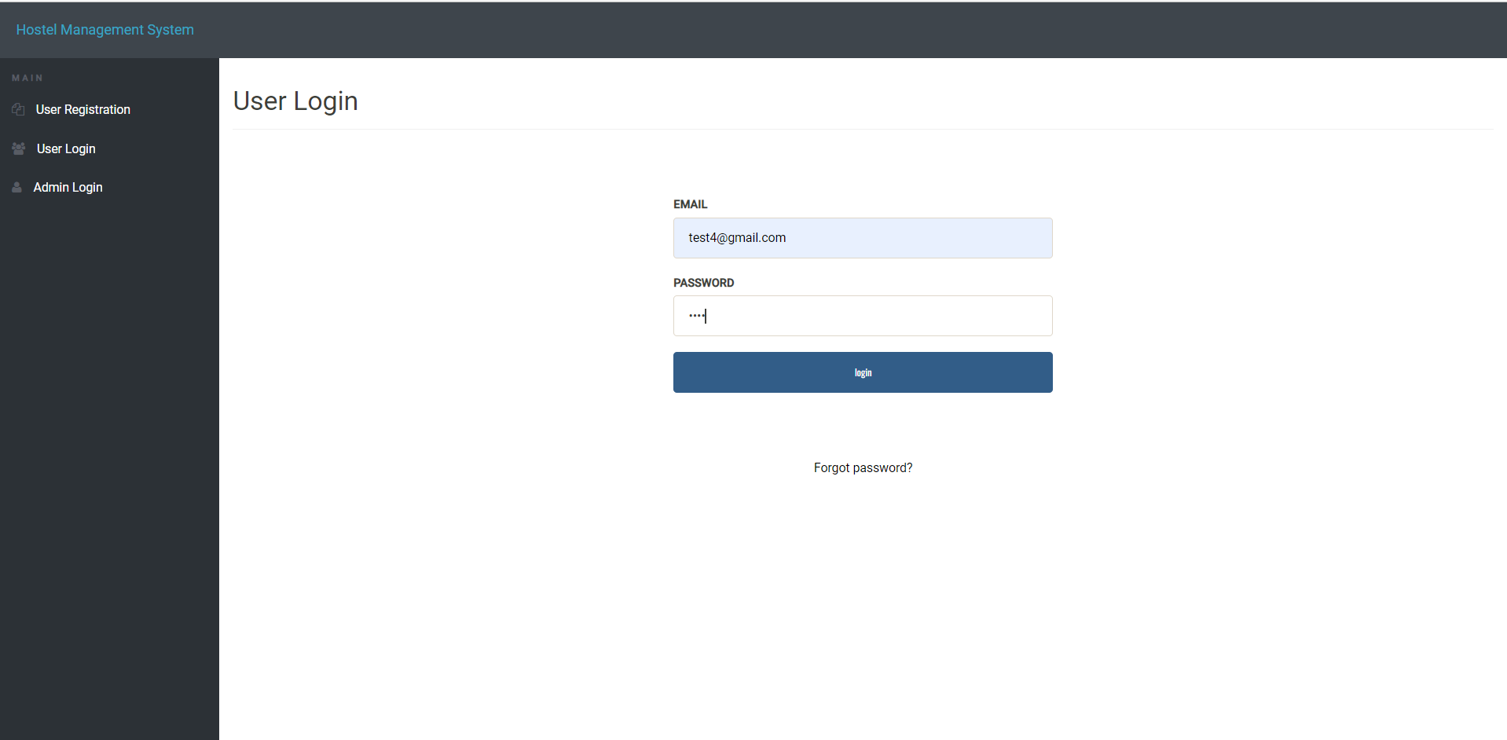

**FIG 5.1:USER LOGIN**

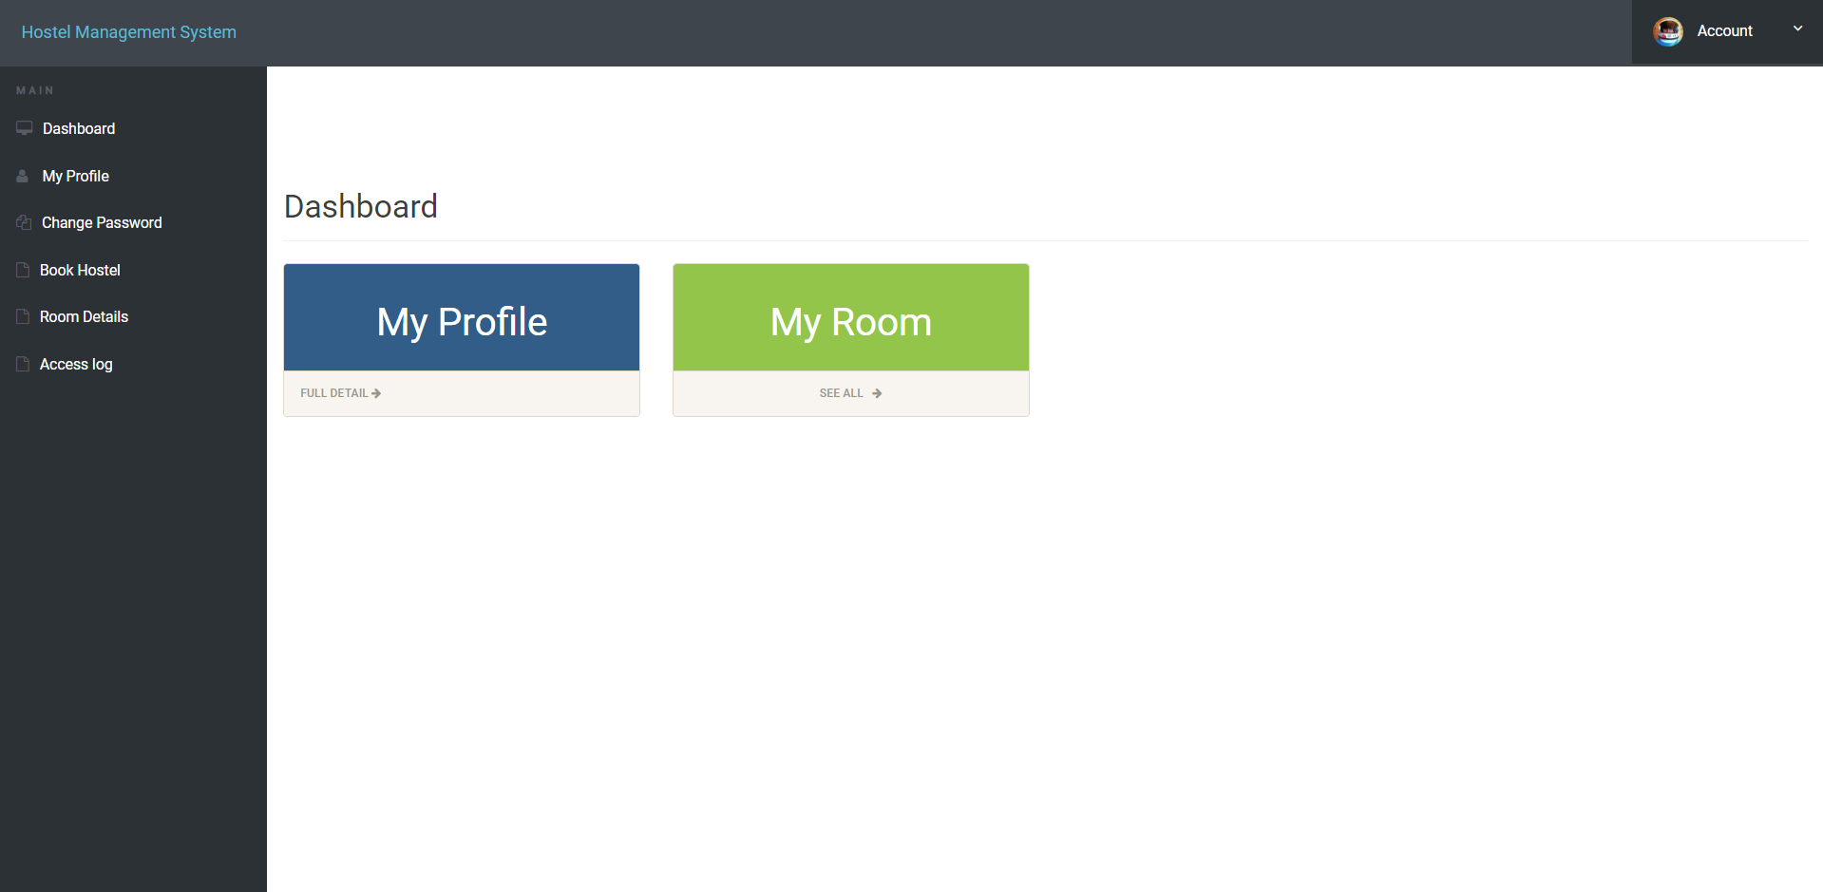

**FIG 5.2: DASHBOARD**

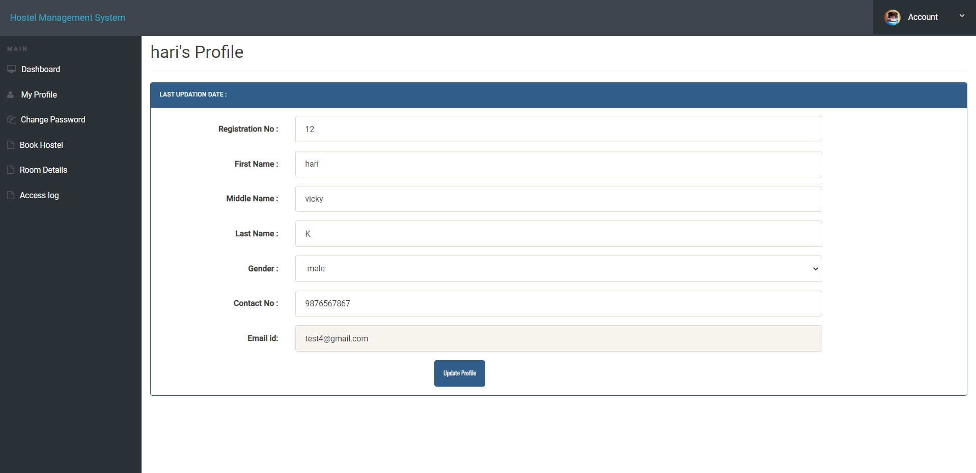

**FIG 5.3:MY PROFILE**

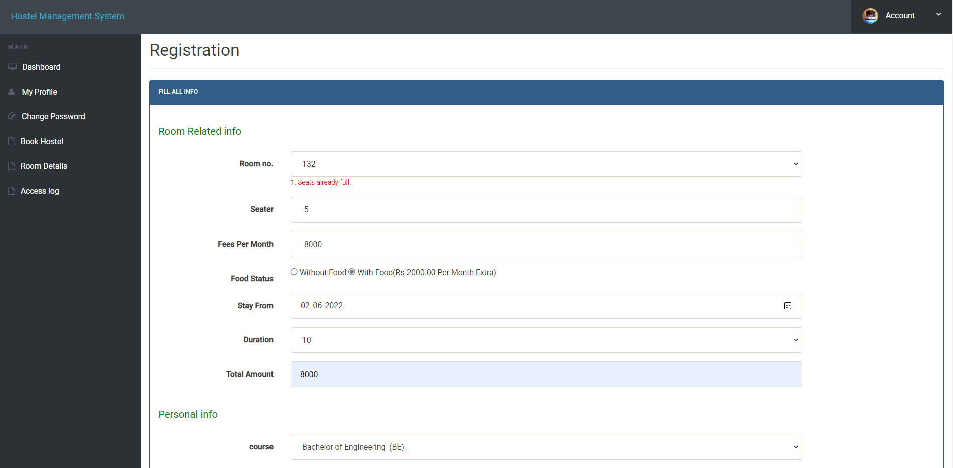

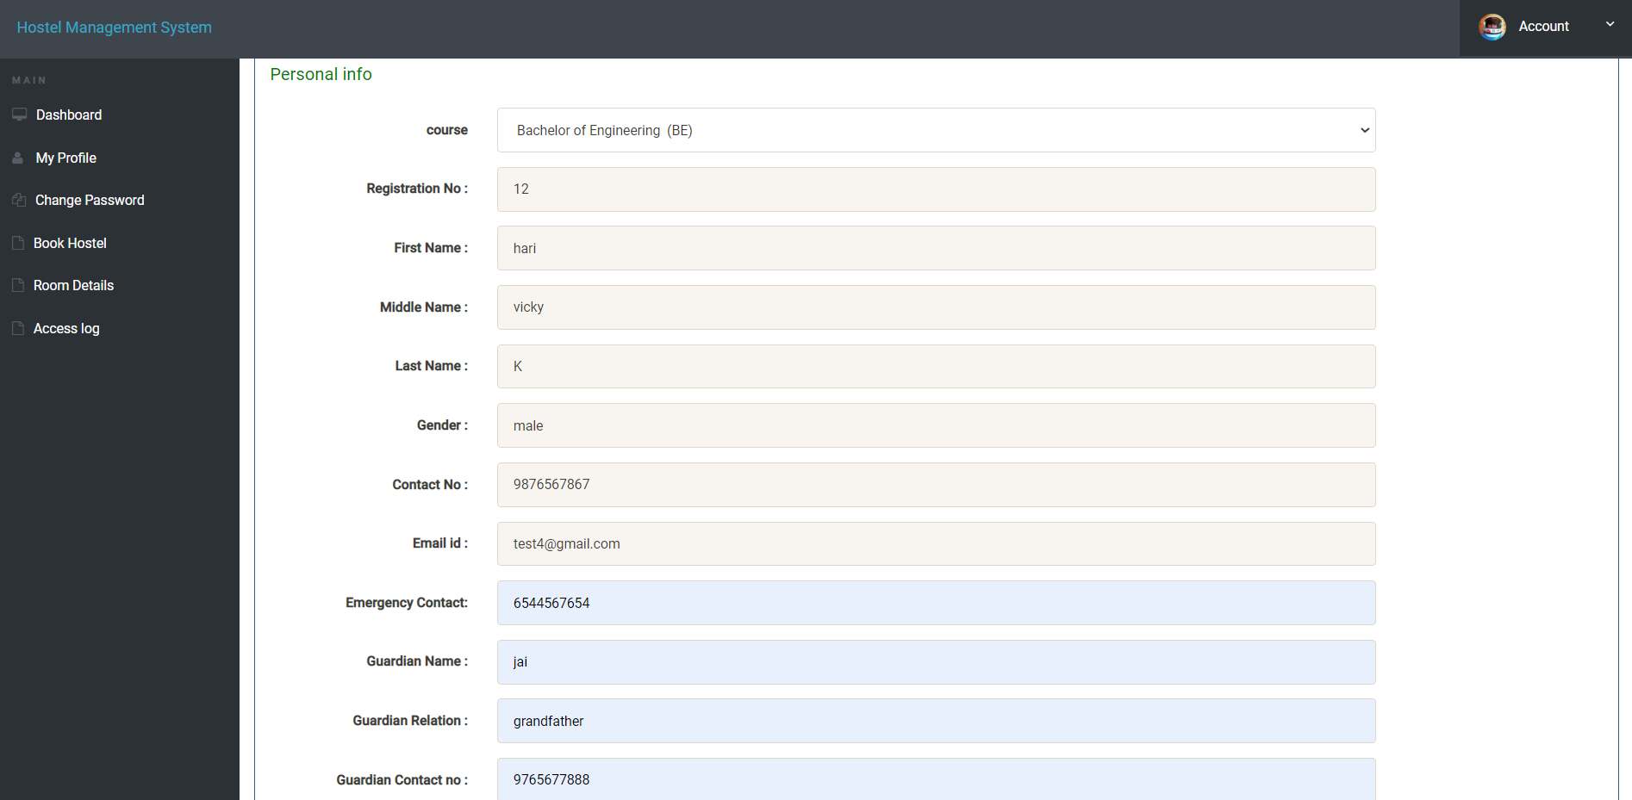

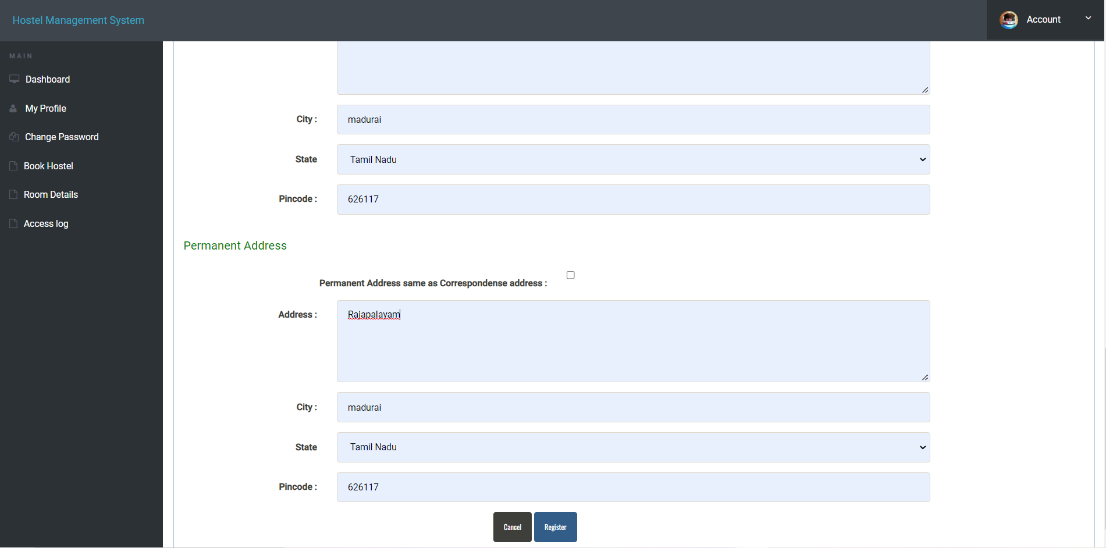

**FIG 5.4:BOOK HOSTEL**

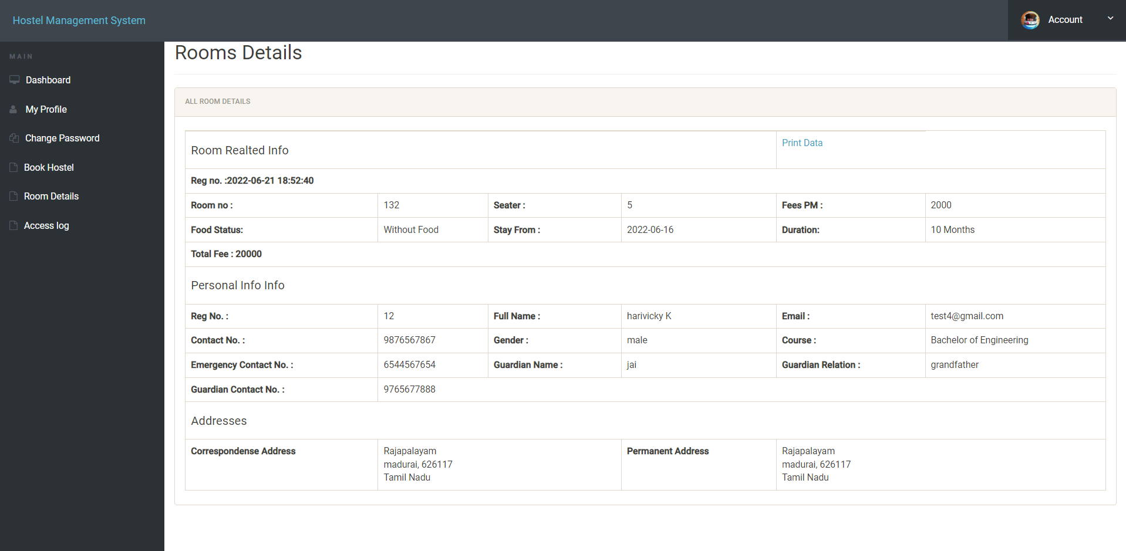

**FIG 5.5:ROOM DETAILS**

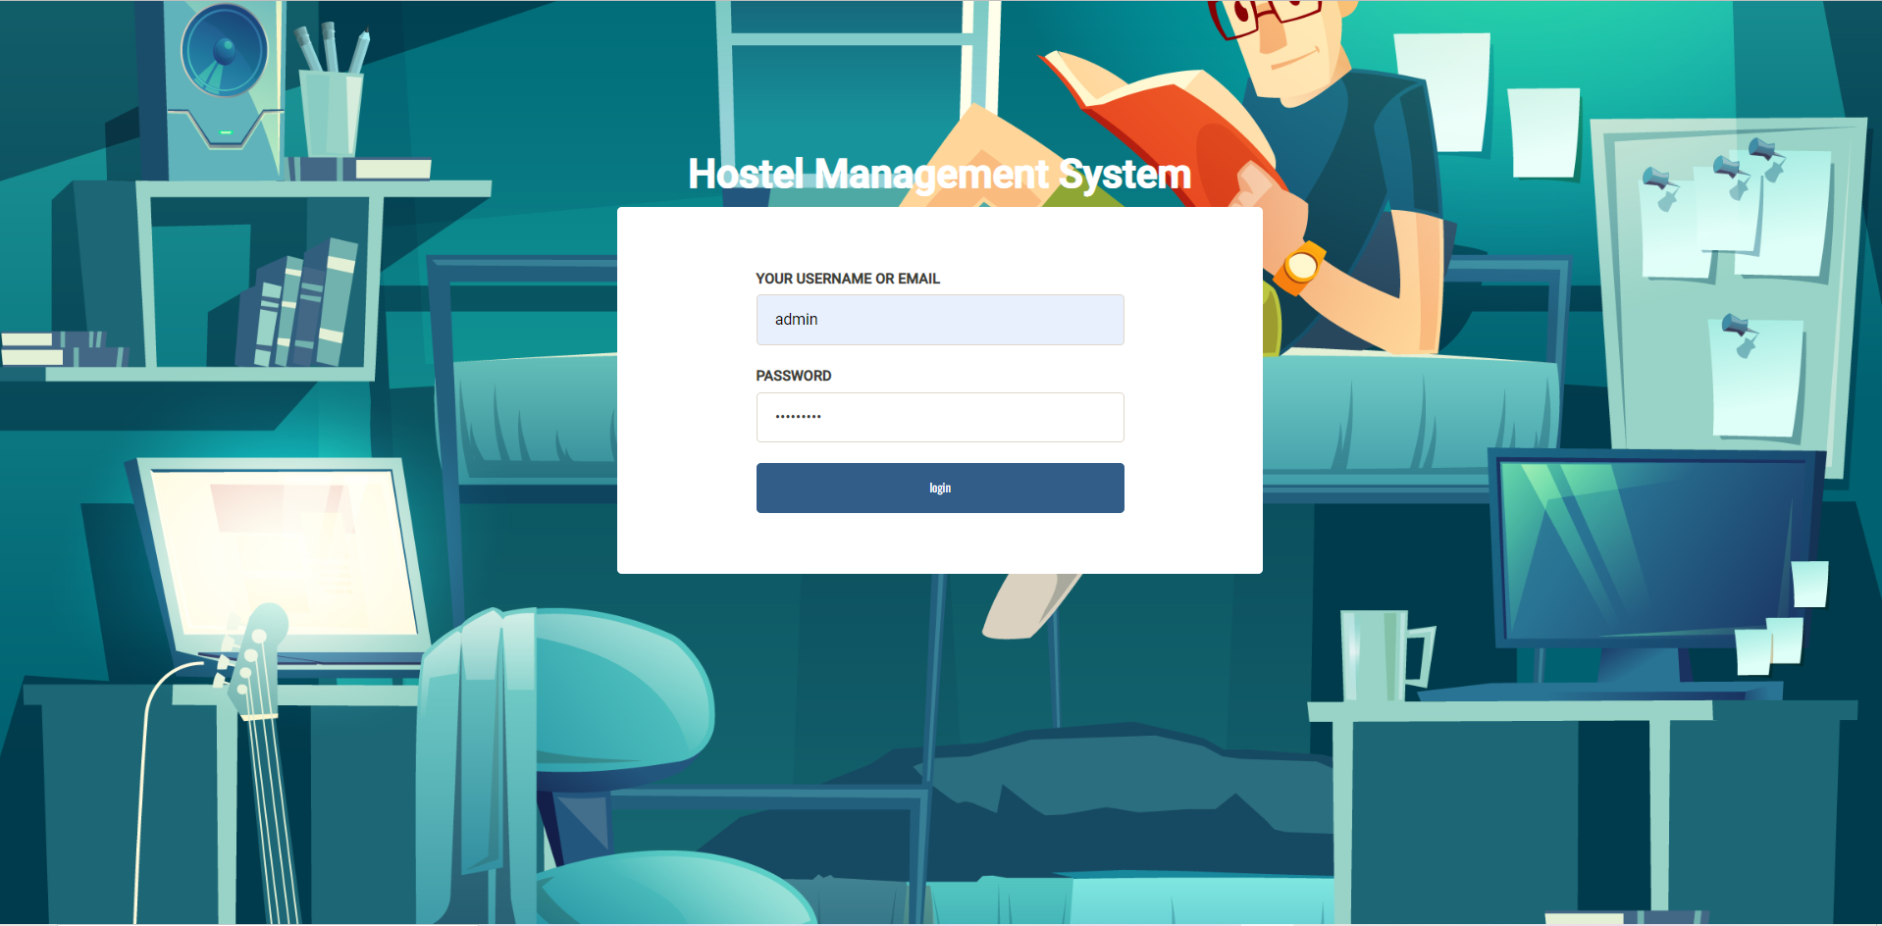

**FIG 5.6:ADMIN LOGIN**

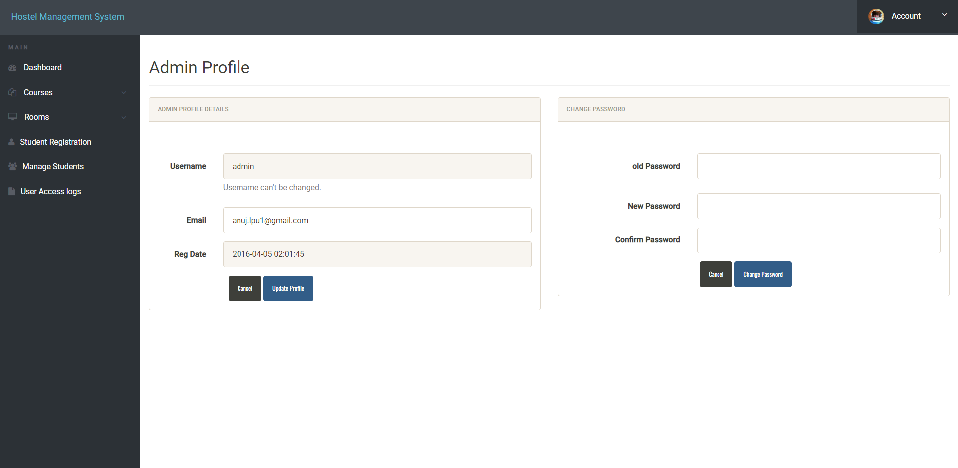

**FIG 5.7:ADMIN PROFILE**

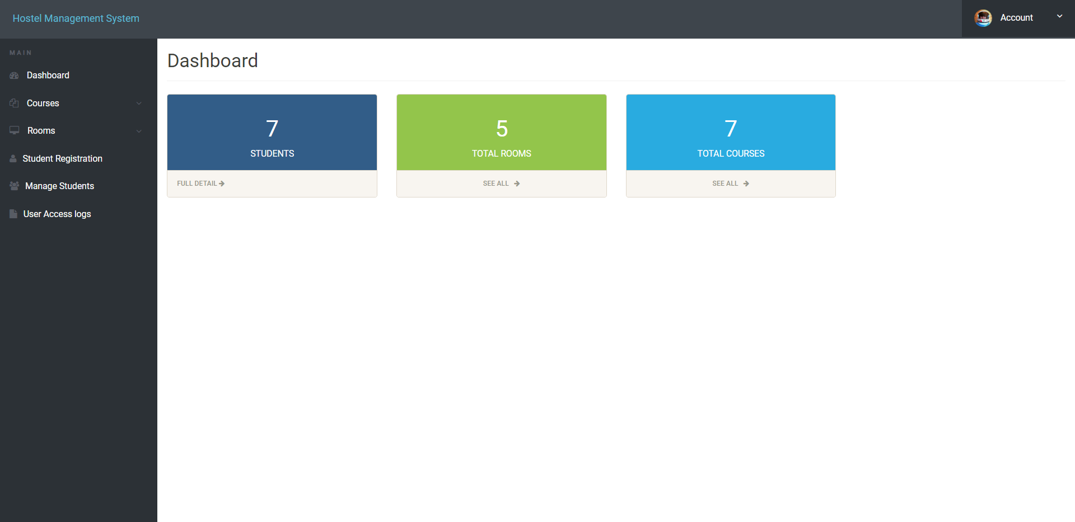

**FIG 5.8:ADMIN DASHBOARD**

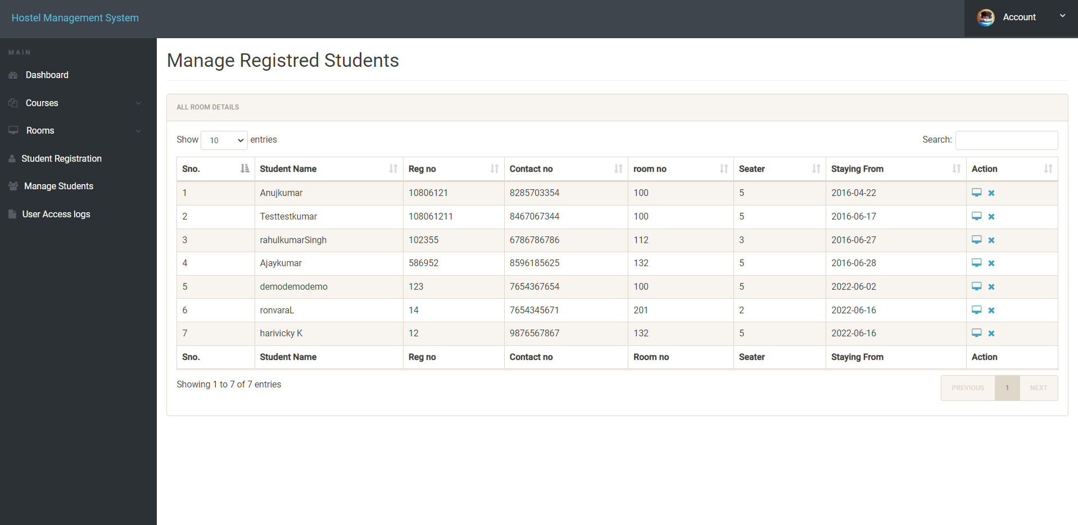

**FIG 5.9:MANAGE REGISTRED STUDENTS**

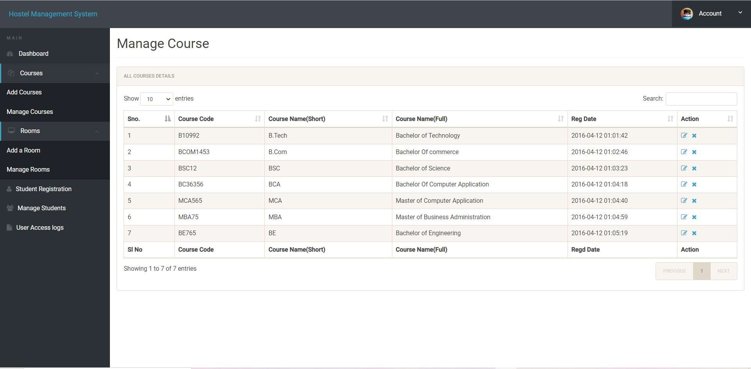

**FIG 5.10:MANAGE COURSE**

**CHAPTER 6**

**CONCLUSION:**

Rather than designing manually we have made use of computer as once that data are input it performs accurate function. There is no chance of fault or miscalculation if the data are given correctly. Use of the computers has solved many problems, which are faced while manual calculation. From a proper analysis of positive points and constraints on the component, it can be safely concluded that the product is a highly efficient GUI based component. This application is working properly and meeting to all user requirements. This component can be easily plugged in many other systems.

**FUTURE WORK:**

Hostel management system This hostel management software is designed for people who want to manage various activities in the hostel. This project is designed to fulfill the need of the future generation. This project is small package which includes different categories as well as having all possible feature. we have expected that it will be helpful to the customers as well as Administrative member. We will improve this project in future with online room reservation system and also improve insecurity by providing a magnetic coated card to permanent student for automatic check in and check out. We are waiting for your future suggestion and encouragement which could make us improve the future programming much better than the one we have carried out

**CHAPTER 7**

**REFERENCES**

**BOOKS:**

* **MySQL – by Paul DuBois.**
* **PHP: A Beginner’s Guide – by Vikram Vaswani.**

**WEBSITES:**

* [**www.javapoint.com**](http://www.javapoint.com)
* **www.geeksforgeeks.com**
* **www.programiz.com**
* **www.beginnersbook.com**